IET Design Camp – Evaluate and Improve Phase
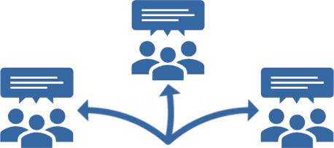
Breakout Group Activity #1
Practice writing outcome and process questions
15 minutes
Activity Instructions
- Read the short narrative of the sample IET program in Appendix D, #D1 in the Participant Guide.
- Select a scribe to capture your group’s ideas in the Evaluation Plan Template on the next page. [NOTE: If you have a group facilitator, he or she will capture the group’s ideas.]
- After reviewing the program description, select the learner, program, or partner goal that you want to evaluate for the program from the following list and write it in the first Goal field of the template on the next page of this activity sheet.
- Learner Goal: Program participants will gain the academic, workforce preparation, and workforce training skills needed to pass the CompTIA certification and to transition to the bridge class to prepare for postsecondary education by the end of the semester.
- Program Goal: Each term, at least 20% of Ability to Benefit IET program participants are from populations identified during the needs assessment as underrepresented (e.g., minorities, females, ELLs, etc.).
- Partner Goal: Throughout the last session of the Ability to Benefit IET program, employer partners will provide work-based learning opportunities that lead to the hiring of program completers.
- As a group, discuss what you would need to know to evaluate that goal, then come to a consensus on one or two outcome questions and one or two process questions for evaluating your selected goal.
- The scribe or group facilitator will write these questions in the rows below the Goal, in the Evaluation Question(s) column. Do not complete the other four columns.
- You have 15 minutes to complete this activity. If you have extra time, come up with more questions.
- Select a spokesperson to share your goal and questions with the whole group.

Goal:

Evaluation Question(s)  (Process & Outcome) | Data Needed​  (Measures)​ | Data Source(s) | Timeframe/  Schedule​ | Analysis Approach  (Quantitative/Qualitative)

IET Design Camp – Evaluate and Improve Phase
Breakout Group Activity #2
Practice creating an evaluation plan
15 minutes
Activity Instructions
- Review the short narrative of the sample IET program in Appendix D, #D1 in the Participant Guide.
- Select a scribe to capture your group’s ideas in the Evaluation Plan Template on the previous page. [NOTE: If you have a group facilitator, he or she will capture the group’s ideas.]
- After reviewing the program description, discuss as a group, the data you need to answer each outcome and process question and evaluate the goal, the data sources for the required data, the timing or frequency of the evaluation, and the analysis approach(es) (i.e., quantitative or qualitative).
- Come to a consensus for each item.
- The scribe or group facilitator will write the group’s decisions in the four right columns of the Program Evaluation Plan Template for each outcome and process question.
- You have 15 minutes to complete this activity.
- Select a spokesperson to share your decisions with the whole group.

