IET Design Camp

Facilitator Guide for
PHASE 3: DEVELOP AND IMPLEMENT

Facilitator Guide for IET Design Camp
Phase 3 – DEVELOP AND IMPLEMENT

Introduction
Welcome to the Facilitator Guide for the virtual or in-person delivery of the IET Design Camp, Phase 3: Develop and Implement. This guide outlines everything you need to know to facilitate the training, including logistics, training materials, learning objectives, timing, and talking points for each slide. Training teams should a) review this guide and the corresponding training materials (see below) and b) make modifications based on who is delivering the training, when s/he will deliver the training, and how s/he will deliver the training.

Logistics
Date: [ENTER DATE]
Time: [ENTER TIME AND TIME ZONE]
Estimated Run Time: 2 – 2.5 hours [EDIT ESTIMATED TIME AFTER CUSTOMIZING SLIDES]
Technical Assistant: [ENTER TECHNICAL ASSISTANT NAME]
Moderator(s): [ENTER MODERATOR NAME(S)]
Trainers/Facilitators: [ENTER TRAINER/FACILITATOR NAME(S)]

Overview
This session will focus on the development of standards-based curricula with a single set of learning objectives (SSLOs) for the IET program. To facilitate discussion and learning, participants will explore the concept of an SSLO within the context of a sample curriculum. In addition, this session discusses the importance of intentionally integrating adult basic education academic standards, workforce preparation skills, and college and career planning skills to prepare adult learners beyond the context of the occupational training. Finally, the session touches on launching the IET program and collecting data that will be evaluated in Phase 4: Evaluate and Improve.

Training Materials
PowerPoint Deck: 3.A1_Develop_and_Implement_PPT.pptx
Participant Guide: Participant_Guide.docx
Breakout Group Activity Files:
- (In-Person and Virtual)
3.B1_Develop_Implement_Breakouts_ 1-2_Facilitator_Guide.docx
- (Virtual Only)
3.B2_Develop_Implement_Breakouts_1-2_Facilitator_PPT_ Virtual.pptx
Toolkit Sections Covered in this Session
Design and Plan
- 3.2 Develop the IET Curricula
- 3.4 Implement the Program and Collect Data
Desk Aids

- IET Planning Tool
- SSLO Template
- Analyze Existing IET Curricular Materials
- Develop Contextualized Instructional Materials
- College and Career Planning
- Integrate Technology into the IET Curricula

Objectives
After completing this session, participants will be able to access and use the relevant resources in the IET Toolkit to develop standards-based curricula with a single set of learning objectives that align the adult literacy, adult education content standards, and workforce preparation skills with occupational training curricula and the accompanying occupational training objectives.
To accomplish this, participants will be able to:
Identify the steps for developing standards-based curricula with a single set of learning objectives for an IET program.
Identify workforce preparation knowledge and skills needed to be successful on the job.
Identify the adult education academic standards that focus on developing academic skills for lifelong learning.
Develop integrated learning objectives across the IET curricula that align with the program-level goals.

3-0 Overview/Introduction
Start Time: [ENTER TIME]

Welcome and Overview of the Training Session
Presenter: [NAME]
Duration: 1 min.
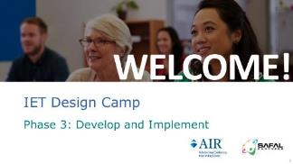
Present:
- Welcome participants to the session and thank them for their continued participation.
- Provide a brief overview of this session.
- This session will cover the Develop and Implement phase. This is where you’ll build out your IET curricula and launch your program. As you implement your program, you’ll collect data that you’ll analyze during Phase 4: Evaluate and Improve.
- As we discussed in previous sessions, WIOA requirements state that IET programs must have a single set of learning objectives, which we’ll refer to in this training as the “SSLO,” that integrate the occupational training, adult education, and workforce preparation activities. In this session, we’ll focus on the development of an SSLO and building out the activities and lessons of your contextualized curricula.
- You’ll get an opportunity during this session to apply what you learn in a couple of breakout group activities.
NEXT SLIDE

Virtual Meeting Recording Notice (OPTIONAL)
Presenter: [NAME]
Duration: .5 min.
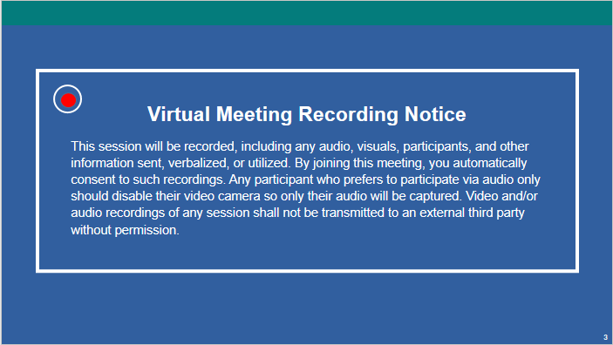

NOTE – IET Design Team:
- This is an optional slide. If you are delivering the training in person or do not need a recording notice, delete this slide from the PowerPoint slide deck and from this Facilitator Guide.
Present:
- Remind participants that this session will be recorded and direct them to the disclosure on the slide.
NEXT SLIDE

Virtual Classroom Reminders (Optional)
Presenter: [NAME]
Time: .5 min.
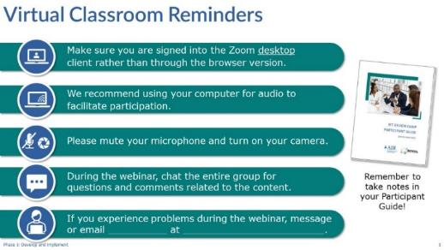
NOTE – IET Training Team:
- This is an optional slide. If you are delivering the training in person, delete this slide from the PowerPoint slide deck and from this Facilitator Guide. If you are delivering the training in another platform, edit this slide accordingly.
Present:
- Review virtual classroom reminders.
- Please take a moment to read through these reminders and make sure you’re ready to participate in the session.
- I hope you have your Participant Guide open with your questions and notes from your reading assignment and that you’re ready to dive into today’s session.
NEXT SLIDE

Agenda
Presenter: [NAME]
Duration: 1 min.
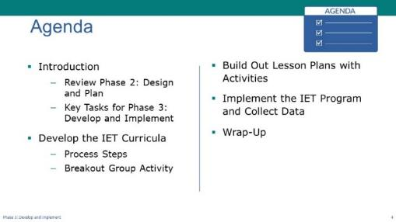
Present:
- Review the agenda
- We’ll start, as always, with a brief review of phase 2 and key tasks for phase 3.
- The biggest chunk of today’s session will focus on the steps to develop a standards-based IET curricula with a single set of learning objectives. We’ll then split into breakout rooms where you’ll get to practice some of the concepts.
- Next, we’ll move into building out contextualized lesson plans with activities
- Then we’ll talk briefly about launching your IET program and collecting data that you’ll analyze in the Evaluate and Improve phase.
- We’ll wrap up the session with key takeaways, an opportunity to reflect on what you learned and ask any remaining questions, and then next steps.
NEXT SLIDE

Poll: IET Components (Optional)
Presenter: [NAME]
Duration: 2 min.
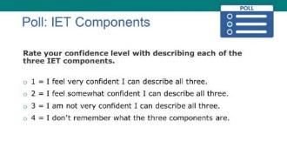
NOTE – IET Training Team:
- This is an optional poll designed to engage participants in the content for this session. You can delete or modify it as needed and adjust the time spent on discussion results according to your priorities.
Poll:
- Introduce the poll question.
- Before we dive into our discussion of the single set of learning objectives, let’s take a quick poll.
- We talked in previous sessions about the three required components of an IET program. How confident are you that you can describe each of the components?
- [In-person] Read the options and have participants raise their hands.
- [Virtual] Ask the technical assistant to launch the poll and give participants a little time to respond, then ask the technical assistant to share the results.
- Discuss the results and let participants know that, if they aren’t confident about their ability to describe all three components, this session will help them gain a better understanding.
- Remind participants that the three components must be provided concurrently and contextually and organized around a single set of learning objectives. In this session we’ll talk about what that means and what it might look like.
NEXT SLIDE

Today’s Trainers
Presenter: [NAME]
Duration: 1 min.
Present:
- Introduce the trainers or have them introduce themselves.
NEXT SLIDE

IET Design Camp – We are Here
Presenter: [NAME]
Duration: .5 min.
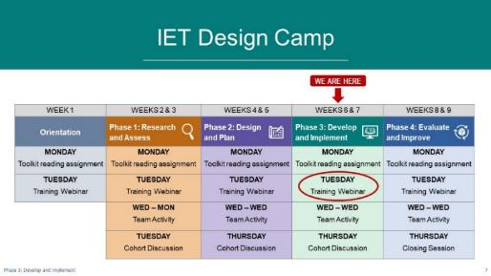
NOTE – IET Training Team:
- You should have already developed a table that reflects the structure and organization of your Design Camp for the Orientation session. You may want to just copy and paste your table onto this slide and move the “WE ARE HERE” and arrow to the Phase 3 session. You may want to circle the activity you are on (Training Session).
- Tailor your talking points to reflect the design and schedule of your training (e.g., you may not be doing a cohort meeting.)
Present:
- Orient participants to where you are in the Design Camp—Phase 3.
- Let’s look at where we are in the Design Camp. As you can see, we’re in the home stretch!
- Hopefully you read your Toolkit reading assignment and took notes in your Participant Guide.
- After today’s session, you’ll get together with your local teams for your team activity, which we’ll discuss in our wrap-up.
- We’ll reconvene [ENTER DATE] for your cohort discussions.
- And then we have one more training session after this.
NEXT SLIDE

Review of Phase 2: Design and Plan
Presenter: [NAME]
Duration: 3.5 min.
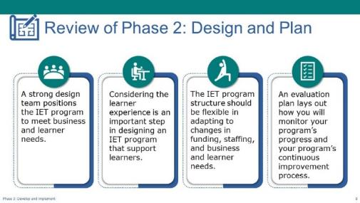
Present:
- Provide review of key concepts Phase 2: Design and Plan.
- Before we jump into the content for today, we wanted to briefly review key concepts from the previous training session, which covered Phase 2: Design and Plan.
- We talked about the value of a strong design team, and the importance of articulating learner, program, and partner goals, all of which should position the IET program to meet business and learner needs.
- We spent a good amount of time talking about analyzing learners’ needs, including understanding cultural and ethnic differences, and planning for the learner experience as an important step in designing an IET program that supports learners.
- We also discussed the need to keep your program structure flexible so you can easily adapt to changes in funding, staffing, and business and learner needs.
- We touched on the four stages of the learner experience, which are pre-enrollment, enrollment and intake, participation, and transition to a career or additional education or training opportunities, and we looked at some of the considerations for each phase.
- Finally, we briefly discussed the importance of embedding evaluation into your program design through an evaluation plan that lays out how you’ll monitor the progress your program is making and how you’ll collect and use data to inform program improvement efforts. During today’s session we’ll touch on collecting data according to your evaluation plan as you implement your planned intervention strategies and deliver your training. In our next session, we’ll go into more depth about evaluation planning and analyzing and sharing the data you collect.

- Ask if there are any questions about the concepts we covered or the content in the Toolkit for the Design and Plan phase.
NEXT SLIDE

Key Tasks for Develop and Implement Phase
Presenter: [NAME]
Duration: 1 min.
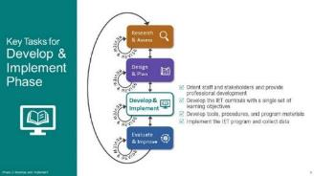
Present:
- Briefly review the key tasks for the Develop and Implement phase.
- As noted on the slide, there are four key tasks in the Develop and Implement phase:
- Orient staff and stakeholders and provide professional development
- Develop the IET curricula with a single set of learning objectives
- Develop tools, procedures, and other program materials
- Implement the IET program and collect data
- Explain the primary focus of the session.
- We’re going to focus primarily on the second task, as there’s a lot to unpack in that task.
- We’ll also briefly touch on implementing the plans you developed as you launch the program and start collecting data.
- The IET Toolkit provides detailed information and desk aids for the other two tasks.
NEXT SLIDE

Group Discussion – Reflect on Your Reading
Presenter: [NAME]
Duration: 4 min.
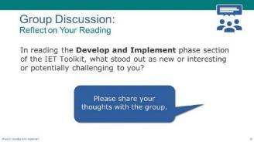
Discuss/Chat:
- Facilitate a discussion on the following question:
- In reading the Develop and Implement phase section of the IET Toolkit, what stood out as new or interesting or potentially challenging to you?
- [Virtual] Have participants share responses in the chat or unmute their microphone to speak.
- [In-Person] Ask participants to raise their hand or call out responses.
NEXT SLIDE

3-1 Develop the IET Curricula
Start Time: [ENTER TIME]

Develop the IET Curricula – Topic Intro
Presenter: [NAME]
Duration: 1 min.
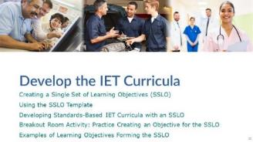
Present:
- Introduce the topic and subtopics.
- We’re going to start by talking about a key WIOA requirement of IET programs—the single set of learning objectives, or SSLO.
- Next, we’ll introduce the SSLO Template in the IET Planning Tool and show how you can use it as a starting point for building out your lesson plans and activities for your program.
- The biggest portion of this topic centers around the steps for developing a standards-based IET curricula around a single set of learning objectives. We’ll introduce two approaches, but we’ll walk through one in detail.
- At the end of this topic, we’ll give you an opportunity to practice creating a learning objective that would be a part of an SSLO for a sample IET program, and we’ll follow up that activity with an example of learning objectives for an IET curricula forming the SSLO.
NEXT SLIDE

Creating Integrated Learning Objectives to Form a Single Set of Learning Objectives (SSLO)
Presenter: [NAME]
Duration: 1 min.
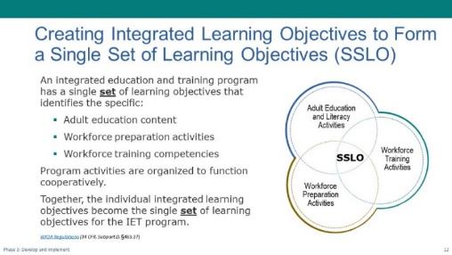
Present (1 min):
- Explain the WIOA requirement of having a single set of learning objectives for IET programs.
- As you know, WIOA requires that the IET curricula be designed and developed around a single set of learning objectives. But what is a single set of learning objectives?
- Hopefully, you all read the Develop and Implement section of the Toolkit and you have a general understanding of what that means, but let’s briefly review.
- The learning objectives that will make up an IET program’s SSLO identify and integrate the specific adult education content, workforce preparation activities, and workforce training competencies.
- The program activities must be organized to function cooperatively as a whole.
- You’ll see how, together, the individual integrated learning objectives you create for the entire curricula become the IET program’s single set of learning objectives. [Emphasize “set.”]
NEXT SLIDE

SSLO Template
Presenter: [NAME]
Duration: 2 min.
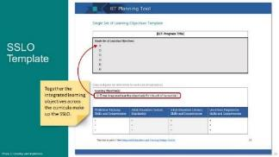
NOTE – Technical Assistant:
- This slide has one build (click). When prompted, click to display the callouts (see below).
Present:
- Introduce and provide an overview of the SSLO Template.
- The IET Planning Tool has an SSLO Template that you can use to guide your development of your SSLO and organize the skills, competencies, and standards for your units of instruction. We’ll practice doing that a little later in this session.
- You can see that the template includes a field to enter the name of your IET program at the top and then your single set of learning objectives right below the title.
- Then, below that area is a separate table that you can copy and paste for each unit of instruction in your curricula. In the top area of this table, you’ll enter the integrated learning objective or objectives for the unit of instruction. You may have more than one learning objective for a unit.
- Below that you’ll enter the skills and competencies for each of the three required components, as well as the state adult education standards associated with the objective or objectives for that unit of instruction.
[CLICK TO DISPLAY THE CALLOUT AND ARROW]
- Each integrated learning objective you create for your units of instruction across the curricula combine to make up the SSLO. So, the entire list of objectives goes in that top gray section.
- Next, we’ll look at the function of an SSLO and review a couple of approaches for developing your IET curricula with a single set of learning objectives.
NEXT SLIDE

The Function of the SSLO: Approach #1
Presenter: [NAME]
Duration: 2 min.
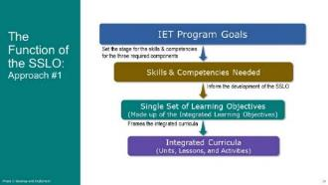
Present:
- Use the graphic on the slide to briefly explain the function of the SSLO for one way to develop IET curricula.
- Remember that WIOA doesn’t prescribe the process of creating standards-based curricula around a single set of learning objectives. The Toolkit lays out two approaches.
- Both approaches we’re going to discuss use the IET program-level goals you developed in the Design and Plan Phase as a foundation. Remember these are the overarching program, partner, and learner goals.
- In the first approach, which is depicted here, you begin with existing workforce training curricula and then identify the embedded adult education and workforce preparation skills and competencies needed into it. These will inform the development of the integrated learning objectives that will make up the SSLO.
- The SSLO will frame the development of the integrated curricula.
- We’ll go through this approach in detail next, and then we’ll briefly introduce another approach.
NEXT SLIDE

Steps to Developing Standards-Based IET Curricula with a Single Set of Learning Objectives: Approach #1
Presenter: [NAME]
Duration: 2 min.
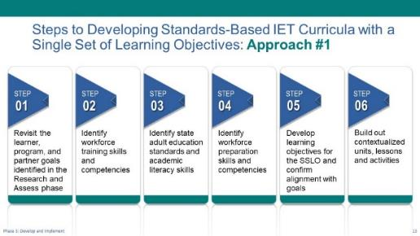
Present:
- Briefly review the steps on the slide.
- The first step in any approach you take should be to revisit your program-level learner, program, and partner goals you identified in Phase 1.
- The next step in this approach is to identify the workforce training skills and competencies.
- Next, you’ll identify relevant state adult education standards and academic literacy skills.
- Then you’ll identify the workforce preparation skills.
- Once you’ve identified the skills and competencies for all three required components as well as the adult education standards, you’ll create one or more learning objectives for each unit of instruction, by integrating the identified workforce training skills, state adult education standards and literacy skills, and the workforce preparation skills. Again, the learning objectives you create across the curricula will combine to become the SSLO. Part of this step is to confirm alignment of your SSLO with your program goals.
- The final step is to build out your contextualized units of instruction with lesson plans, activities, and assessments.
- Connect the process to current curriculum development processes and set expectations for the walkthrough.
- This process may be new to some of you, and for some it may align closely with the process you already use to develop your IET scope and sequence or curriculum map. You may just need some practice in rounding out what you already do to ensure that your IET is well-integrated and in compliance with WIOA requirements.
- We’ll walk through the steps for one approach and then we’ll talk a bit more about the process and how it aligns with what you are (or are not) doing.
- Keep in mind that this will be a quick walk through of the process. We’re not going to be taking a deep dive into curriculum development here. But you’ll have a chance to dig a little deeper into this in the upcoming team activity [if virtual] and your next cohort discussion.
- Discuss the importance of inviting partners to this process.
- It’s particularly important to engage your training partners in the process, as they can help identify the training/industry objectives and competencies. You can also help them think through the needed academic skills or academic skills that promote literacy development beyond the IET and that often present problems for learners.
NEXT SLIDE

Step 1: Revisit the program-level goals identified in the Research and Assess phase
Presenter: [NAME]
Duration: 2 min.
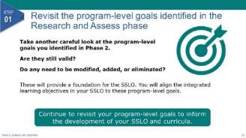
Present:
- Explain step 1.
- As we mentioned, the first step in any approach you use to build your IET curricula is to revisit the program-level goals you identified in the Design and Plan Phase. These are the learner, program, and partner goals that represent what you intend to accomplish with your program.
- You may have made some design decisions along that way that have impacted your goals. As you carefully assess each one, decide as a team whether it is still a valid goal. If it’s no longer valid, remove it from your list so that you are working from a current set of goals as you begin to build out your curricular materials. If any modifications are needed, now is the time to make them.
- Your updated set of program-level goals will provide the foundation for your SSLO, as you’ll later align each of the integrated learning objectives in your SSLO to these goals.
- As you move through the steps for building out your units of instruction and curricular materials, continue to revisit your program-level goals to ensure alignment.
NEXT SLIDE

Step 2: Identify workforce training skills and competencies
Presenter: [NAME]
Duration: 2 min.
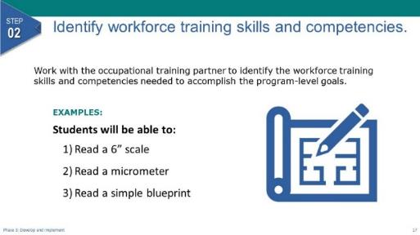
NOTE – Technical Assistant:
- This slide has 1 build/click. When prompted, click to display the examples (see below).
Present:
- Explain step two.
- Once you’ve re-evaluated your program-level goals, you’ll start identifying the workforce training skills and competencies learners in your program will need to accomplish them. Typically, you’ll start with the existing occupational training and identify or refine the workforce training skills and competencies that are covered in the curricula.
- Let’s look at a few examples of some workforce training skills and competencies for a manufacturing IET program.
[CLICK TO DISPLAY THE EXAMPLES]
Students will be able to: read a 6-inch scale, read a micrometer, and read a simple blueprint.
- You can see that these are all skills and competencies that are related to the occupational training component.
- Review the example learner goal:
NEXT SLIDE

Step 3: Identify adult education standards and align adult education literacy skills and competencies
Presenter: [NAME]
Duration: 1 min.
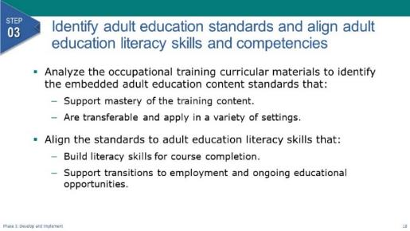
Present:
- Explain step 3.
- The next step in this approach is to identify the adult education standards and align the necessary adult education skills and competencies needed to meet the standards.
- To do this you’ll analyze the occupational training curricular materials and look for the adult education content standards that are embedded in the curriculum and that will support mastery of the training content and that provide opportunities to develop strong academic skills that are transferable and apply in a variety of settings.
- You’ll align those standards to adult education literacy skills that build literacy skills for course completion and that support transitions to employment and ongoing educational opportunities.
NEXT SLIDE

Step 4: Identify workforce preparation skills and competencies
Presenter: [NAME]
Duration: 1 min.
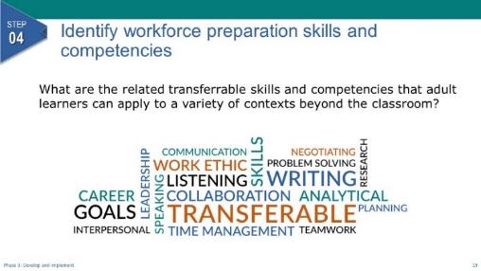
Present:
- Explain Step 4.
- Next, you’ll identify the workforce preparation skills and competencies related to, or embedded in, the occupational training.
- What are the transferrable skills and competencies that employers in the industry focus of your IET program look for in an employee?
- You may know these as employability skills, soft skills, or 21st-century skills. These are the skills and competencies that adult learners can apply to a variety of contexts beyond the classroom.
- You can see some common workforce preparation skills in the word cloud on the slide—collaboration, problem solving, time management, speaking, leadership, etc. These must be taught in the context of the workforce training instruction. You can see how they can overlap with adult literacy skills and competencies.
NEXT SLIDE

Step 4 (CONT.): Identify workforce preparation skills and competencies - Resources
Presenter: [NAME]
Duration: 1 min.
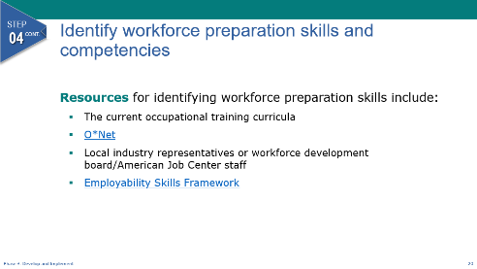
Present:
- Review the resources on the slide.
- There are several resources to help you identify workforce preparation skills. For example, you can:
- Analyze the occupational training curricula itself to see where workforce preparation skills might come into play.
- Consult O*Net, which has detailed descriptions of the world of work for use by job seekers, workforce development and human resource professionals, students, and researchers.
- Consult with local industry representatives or Local Workforce Development Board/American Job Center staff.
- You’ll also want to bring your professional knowledge and experience to bear to identify workforce preparation skills that will ready learners to transition to employment or additional learning contexts.
- Be sure to include any skills related to required credentials and/or licensures.
- In doing this work, you may want to use a workforce preparation skills framework, such as the Employability Skills Framework. The skills in this framework align closely to workforce preparation skills. Some states have developed their own list of employability skills, so be sure to check with your state. Using a framework can help you identify workforce preparation skills and to facilitate communication with the training partner (it will help to have a common language).
NEXT SLIDE

Step 5: Develop integrated learning objectives for the SSLO and confirm alignment with goals
Presenter: [NAME]
Duration: 3 min.
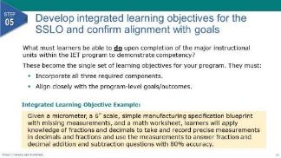
NOTE – Technical Assistant:
- This slide has 1 build/click. When prompted, click to display the example (see below).
Present:
- Explain step five.
- Now that we’ve identified the skills for the three required components it’s time to create integrated learning objectives for each major unit of instruction across the curricula. These objectives will collectively become the single set of learning objectives around which you’ll build your contextualized IET curricula. They must clearly articulate what the learner must be able to do for you to evaluate competency. They must incorporate all three required components and they must align closely with the program-level goals and outcomes you created in the Design and Plan phase.
- The integrated learning objectives must describe what learners must be able to do upon completion of the major instructional components within the IET program to demonstrate competency or proficiency.
- A couple of things to note about the integrated learning objectives:
- They may be similar to some of your program-level learner goals but should be at a more granular level, such as the unit or quarter level, rather than at the program level.
- They are a great source for determining your assessment strategies, as they are performance-based.
[CLICK TO DISPLAY THE EXAMPLE]
- For example, in a manufacturing IET program, one integrated learning objective might be:
“Given a micrometer, a 6” scale, simple manufacturing specification blueprint with missing measurements, and a math worksheet, learners will apply knowledge of fractions and decimals to take and record precise measurements in decimals and fractions and use the measurements to answer fraction and decimal addition and subtraction questions with 80% accuracy.”
- Notice that it integrates workforce training skills, adult education skills, and workforce preparation skills. This could very well support a program-level learner goal. It could also be used as a jumping off point for the assessment. We’ll talk more about determining assessment strategies a bit later.
NEXT SLIDE

Step 5 CONT: Develop integrated learning objectives for the SSLO and confirm alignment with goals – A Closer Look
Presenter: [NAME]
Duration: 4 min. total
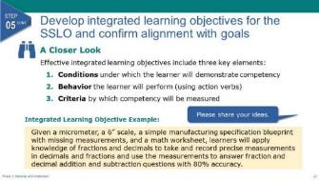
NOTE – Technical Assistant:
- This slide has one build (click). When prompted, click to display the example (see below).
Present (1 min.):
- Explain the three key elements of an effective performance objective.
- Remember that these must be measurable. So, to say that learners need to know or understand something is not measurable. How will you determine whether they know or understand something? They’ll show you, right?
- An effective performance objective has three key elements that describe:
- The conditions under which the learner will demonstrate competency.
- The behavior or action the learner will perform to demonstrate competency, described with action verbs.
- The criteria by which competency will be measured.
- Let’s look at our example integrated learning objective again and see if we can identify all three of these elements.
[CLICK TO DISPLAY THE EXAMPLE AGAIN]
Discuss/Chat (3 min.):
- Facilitate a discussion on the three questions below and provide guidance as needed.
- [Virtual] Have participants share responses in the chat or unmute their microphone to speak.
- [In-Person] Ask participants to raise their hand or call out responses.
- What are the conditions under which learners will demonstrate competency?
Look for: Learners will be given a micrometer, a 6” scale, a simple manufacturing specification blueprint with missing measurements, and a math worksheet.
- What are the action verbs that describe the behavior?
Look for: apply; take; record; use; answer
- And what is the criteria by which competency will be measured?
Look for: 80% accuracy
NEXT SLIDE

Step 5 CONT: Develop integrated learning objectives for the SSLO and confirm alignment with goals – Reminder
Presenter: [NAME]
Duration: .5 min.
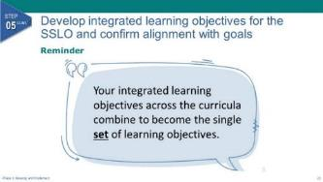
Present:
- Explain the reminder on the slide.
- As a reminder, each of the integrated learning objectives—of which you can have more than one per instructional unit or section—will combine to form the single set of learning objectives for your IET program.
NEXT SLIDE

Step 5 CONT: Develop integrated learning objectives for the SSLO and confirm alignment with goals – SSLO rubric
Presenter: [NAME]
Duration: 3.5 min.
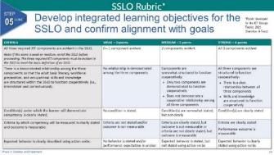
Present:
- Introduce the SSLO rubric.
- Because the SSLO is instrumental in guiding the development of the curricula for an IET program, we suggest using a rubric to ensure that you have created strong, integrated learning objectives that are performance based.
- Here are the key criteria for the rubric:
- Are all three required components represented and evident?
- Are the components integrated?
- Is the condition under which competency will be measured clearly stated?
- Are the criteria by which competency will be measured clearly stated?
- Is the behavior or action the learner will perform to demonstrate competency clearly stated using action verbs? In other words, are the objectives clearly stated so that expectations and goals are easily identified and understood by the learner?
- As you may notice, the SSLO is a tool to not only align your IET components but also an effective way to communicate the goals of your IET for all stakeholders, which includes your learners. It’s also a great starting point for developing your assessments, as they should be closely tied to your integrated learning objectives.
- In just a bit, you’ll get the opportunity to use this sample rubric and apply what you’ve learned.
- The rubric is in your Participant Guide, Appendix C, and is part of the Toolkit, in Desk Aid 5.
NEXT SLIDE

Step 5 CONT: Develop integrated learning objectives for the SSLO and confirm alignment with goals – Goal Alignment
Presenter: [NAME]
Duration: 1.5 min.
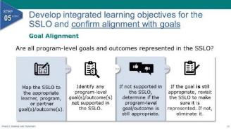
Present:
- Use the PPT slide to discuss aligning the SSLO to program-level goals.
- You’ve created your SSLO and identified the knowledge and skills needed in each of the three required components to demonstrate competency for each learning objective. Now you need to take another look at your program-level goals and outcomes and confirm alignment of your SSLO to them. Are all the program-level goals represented adequately in the SSLO?
- Here’s how you can confirm they are:
- Map each learning objective in the SSLO to the appropriate program-level goals/outcomes.
- Identify any program-level goals that are not supported by at least one objective in the SSLO.
- If a goal is not supported, you’ll need to determine if it’s still an appropriate goal for the IET. It may not be, and that’s okay. This is where you make the determination and make the necessary changes.
- If you determine that a goal that is not currently supported in the SSLO is still appropriate, you’ll need to revisit your SSLO to make sure you have learning objectives that support it.
NEXT SLIDE

Step 6.: Build out the units, lessons, activities, and assessments
Presenter: [NAME]
Duration: 2 min.
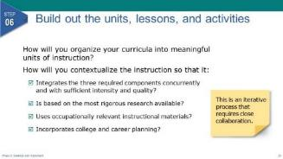

Present:
- Explain step six.
- Once you’ve created your SSLO and aligned standards, skills, and competencies, you are ready to build out the units, lessons, and activities that will enable learners to achieve the learner program goals and attain the necessary credentials and/or licensures for the IET program.
- This is where you’ll determine how to organize your curricula into meaningful units of instruction that are scaffolded to promote success in mastering course content and building transferable skills.
- You’ll make decisions on how best to contextualize the instruction so that it:
- Integrates adult education literacy activities, workforce preparation activities, and workforce training activities concurrently and with sufficient intensity and quality.
- Is based on the most rigorous research available, particularly with respect to improving reading, writing, mathematics, and English proficiency of eligible individuals.
- Uses occupationally relevant instructional materials.
- Remind participants that this is an iterative process.
- This is where the iterative nature of developing IET curricula comes into play. As you’re building out your lesson plans and activities, you may identify additional skills and competencies that you missed in the earlier steps. You may also find that you need to modify your SSLO as you move through the process.
- Again, how you get there is not important. What is important is that you build your curricula around a single set of learning objectives that align with your program goals. Collaboration between adult education instructors and occupational training providers is key in this process.
- We’re going to go into more detail on this step in the next topic, but first we’re going to talk about another approach to developing your IET curricula and then we’ll give you an opportunity to practice creating an integrated learning objective that would be part of an SSLO for a sample IET program.
NEXT SLIDE

The Function of the SSLO: Approach #2
Presenter: [NAME]
Duration: .5 min.
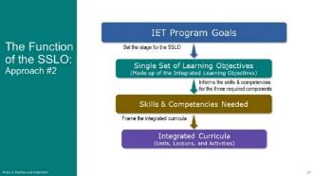

Present:
- Use the graphic on the slide to briefly explain the function of the SSLO for another way to develop IET curricula.
- We mentioned a few times that there are several ways to approach developing your IET curricula around an SSLO. We just walked through one approach. In this second approach, you’ll still start by reviewing and refining your program-level goals. The program goals set the stage for the development of the SSLO, which informs the skills and competencies for the three required components, which frame the integrated curricula. This is more of a top-down approach where you start with the bigger picture and move to the details, whereas the approach we just walked through started with the details of identifying the skills and competencies and then creating the SSLO.
- If you’re searching for occupational skills training or creating the occupational skills training components from scratch, this approach might work best for you.
- Again, the steps are the same as the first approach, just in a different order.
NEXT SLIDE

Steps to Creating Standards-Based IET Curricula with a Single Set of Learning Objectives: Approach #2
Presenter: [NAME]
Duration: 1 min.
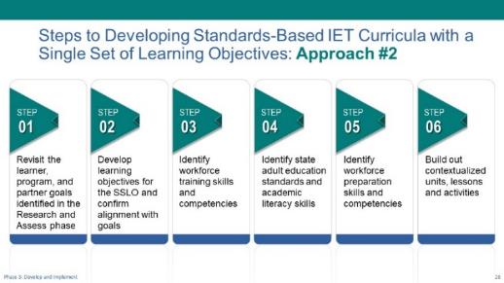
Present:
- Briefly review the steps on the slide depicting another approach to developing IET curricula with an SSLO.
- This slide breaks down the six steps for the second approach. You can see that developing the SSLO step is the second step rather than the fifth step as it was in the other approach.
- As with the other approach we just walked through, you’ll start by revisiting your program-level goals and making any modifications needed now that you’re further along in the process.
- Next, you’ll use your updated program-level goals to create a set of integrated learning objectives that, together, represent achievement of the program-level learner goals. These objectives, of course, make up your SSLO. As before, confirm alignment with your list of program-level goals and outcomes and make any necessary adjustments.
- Then you’ll identify the workforce training skills and competencies needed to accomplish the SSLO.
- Next, you’ll identify relevant state adult education standards and academic literacy skills needed.
- Then you’ll identify the workforce preparation skills needed.
- Once you have those five steps done, you’re ready to build out your contextualized units of instruction with lesson plans, and activities.
NEXT SLIDE

Example: Integrated Learning Objective for an SSLO
Presenter: [NAME]
Duration: 1 min.
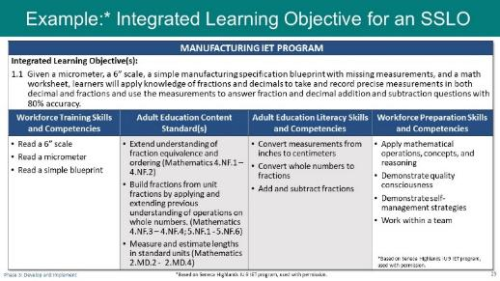
Present:
- Explain the example on the slide of an integrated learning objective with associated skills and competencies for one unit of instruction.
- Here’s an example of what a unit of instruction might look in the SSLO Template for our sample manufacturing IET program. At the top, you can see the integrated learning objective we looked at earlier.
- Again, there could be more than one learning objective for a unit of instruction. This will depend on the size of each unit and the complexity of the content.
- Below the learning objective are the associated skills and competencies for the three required components and the adult education content standards.
- Using this, the curriculum development team can build out their contextualized lessons, activities, and assessments.
NEXT SLIDE

Example: Learning Objectives to Form the SSLO
Presenter: [NAME]
Duration: 1 min.
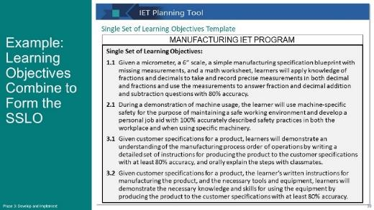
Present:
- Briefly review the SSLO example on the slide.
- Here you can see that we’ve built out additional learning objectives for three units of instruction for our sample IET program and added them to the SSLO Template.
- Notice that the third unit has two integrated learning objectives.
- Let’s see what the fully completed SSLO Template might look like for this partial example.
NEXT SLIDE

Example: Completed SSLO Template
Presenter: [NAME]
Duration: 1 min.
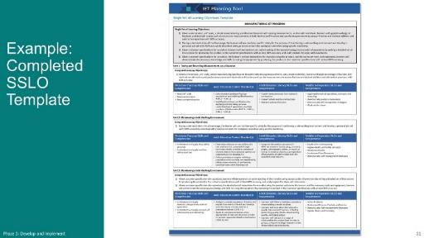
Present:
- Describe the example of a completed SSLO template on the slide.
- Here’s what a completed SSLO Template for a three-unit IET program might look like.
- This template will work whether you begin developing your curricula by creating your SSLO and then identifying the skills and competencies for each of the three required components or by identifying the skills and competencies first and then creating the integrated learning objectives for your SSLO.
- You can see the list of learning objectives that make up the SSLO in the top gray portion.
- Below that section are three separate tables—one for each unit of instruction. As you’re filling out your SSLO Template, you’ll copy and paste the blank lower table in the template and fill them out for as many instructional units as you have in your IET program.
- Ask if there are any questions about the SSLO or the SSLO template.
NEXT SLIDE

Breakout Group Activity #1: Practice creating an integrated learning objective
Presenter: [NAME]
Duration: 20 min. (total)
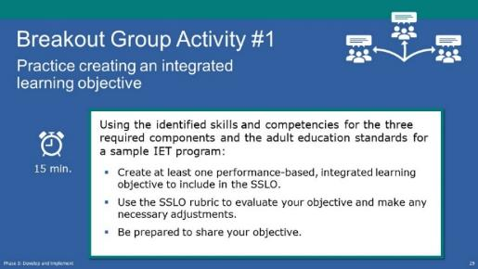
NOTE – IET Training Team:
- You may want to adjust the timing of this activity to allow groups more time to evaluate their integrated learning objective using the SSLO rubric.
- [If virtual] Have the technical assistant set up breakout rooms and assign participants and group facilitators to a room (See tech note below).
- [If in-person] Make sure each group facilitator has a printout of 3.B1_Develop_Implement_Breakouts_1-2_Facilitator_Guide.docx.
Present: (1 min.)
- Explain the activity.
- Now that we’ve walked through the steps and looked at an example, it’s time for you to apply what you’ve learned in a breakout group activity.
- In this activity, you and your group will:
- Review the identified skills and competencies for three required components and the adult education standards for a sample IET program.
- Create at least one integrated learning objective (performance-based learning objective that integrates the 3 IET required components) that will become part of an SSLO.
- If time allows, use the SSLO rubric to evaluate your objective and make any necessary adjustments.
- Select a spokesperson to share your objective(s).
- You’ll have 15 minutes for this activity.
- Advise participants that the IET program example they will be using is the Retail Sales IET Program in Appendix C of their Participant Guide. They may wish to have it handy during the activity, as well as the SSLO rubric.
NOTE – Technical Assistant:
- [If virtual] Assign participants to breakout rooms (add more as needed):
- Room 1 - [FACILITATOR(S) NAME(S)
- Room 2 - [FACILITATOR(S) NAME(S)
- Room 3 - [FACILITATOR(S) NAME(S)
Breakout Group Activity: (15 min.)
BREAKOUT GROUP FACILITATORS:
- [If in person] Use 3.B1_Develop_Implement_Breakouts_1-2_Facilitator_Guide.docx to capture your group’s integrated learning objective(s). You may want to start with a large blank paper and have the group write down their own key ideas as a brainstorming activity. Then use the key ideas on that sheet to develop the learning objective(s).
- [If virtual] Facilitator instructions for facilitating this activity are in 3.B1_Develop_Implement_Breakouts_1-2_Facilitator_Guide.docx. Open the PowerPoint file, 3.B2_Develop_Implement_Breakouts_1-2_Facilitator_PPT_Virtual.pptx and share your screen. Capture your group’s learning objective directly on the slide.
Activity Debrief (4 min.)
- As time allows, call on a few group facilitators to briefly share their group’s integrated learning objective and any insights from the discussion.
- [If virtual] Have facilitators copy and paste their group’s integrated learning objective(s) into the chat window once back on the main room.
NEXT SLIDE

3-2 Build Out Contextualized Lesson Plans with Activities
Start Time: [ENTER TIME]

Build Out Contextualized Lesson Plans with Activities – Topic Intro
Presenter: [NAME]
Duration: .5 min.
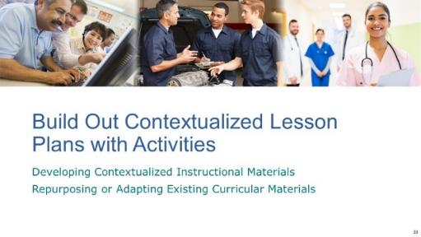
Present:
- Introduce the topic and subtopics.
- Once you’ve developed your SSLO and identified the skills and competencies for the three required components and any relevant adult education standards, you’re ready to begin building out your lesson plans with activities and assessments.
- In this topic, we’ll talk about making sure your lessons and activities are contextualized using occupationally relevant materials.
- We’ll also go over a simple process flowchart for determining whether existing curricular materials can be repurposed or adapted to incorporate into your curricula.
- Again, we’re not going to go into assessments in this training, but we want to emphasize that they should align with your performance-based integrated learning objectives.
NEXT SLIDE

Developing Contextualized Activities and Occupationally Relevant Materials
Presenter: [NAME]
Duration: 1.5 min.
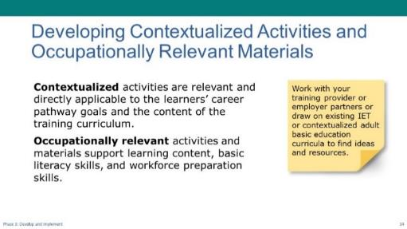
Present:
- Use the PPT slide to talk about contextualized activities and occupationally relevant materials.
- The curricular materials for the training component offer opportunities to contextualize adult literacy and workforce preparation skills so that they are relevant and directly applicable to the learners’ career pathway goals and the content of the training curriculum.
- To contextualize your workforce development and adult basic skills content, you’ll want to build learning activities that include occupationally relevant materials.
- Work with your training provider and employer partners or draw on established IET or contextualized adult basic education curricula to find resources and ideas for learning activities and materials.
- You may need to modify these resources for your identified IET content, learner needs, or level.
NEXT SLIDE

Repurpose or Adapt Existing Curricular Materials for Contextualization and Relevance
Presenter: [NAME]
Duration: 2 min.
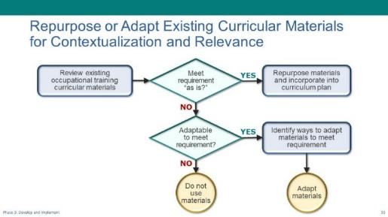
Present:
- Explain the simple flowchart for repurposing or adapting existing materials.
- This simple flowchart shows a process you can use as you assess the curricular materials and determine if you can repurpose (i.e., use “as is”) or adapt them (i.e., modify/edit to suit your purposes) for your course and the accompanying instructional materials.
- Directions:
- You’ll want to work with your team to analyze existing curricular materials. Examine each lesson plan, workbook, activity, resource, and other materials and determine whether they can be leveraged for your IET program—whether “as-is” or with reasonable modifications.
- If it is already contextualized, the adult education literacy skills and workforce preparation skills are integrated and occupationally relevant, and the content aligns with your SSLO, you can incorporate it into the appropriate place in your IET curricula.
- If modifications are needed, brainstorm ideas for how you might adapt them to fit the needs of your program, then select the best approach from your list of ideas.
- Obviously, if you find that it does not fit into your program and adapting the content is not realistically feasible, you won’t use it. This can be a difficult decision sometimes. But if a lesson or activity doesn’t align with the SSLO you created, it’s probably best to not include it in the IET curricula.
NEXT SLIDE

Developing Contextualized Activities Checklist
Presenter: [NAME]
Duration: 1 min.
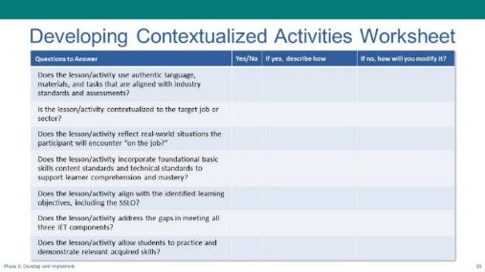
Present:
- Introduce the Develop Contextualized Instructional Materials desk aid.
- The Toolkit includes a desk aid called Develop Contextualized Instructional Materials to guide and evaluate how well you’ve contextualized your lesson or activities.
- You’ll work with your training partner(s) to contextualize the IET curriculum by identifying and addressing gaps in academic, language, and employability/workplace skills that learners need to successfully complete the IET program and transition to employment and/or postsecondary education and training opportunities.
- Work with or get feedback from training or industry stakeholders to ensure materials are contextualized to the target job or sector.
NEXT SLIDE

Using the SSLO to Build Out Your Curricula
Presenter: [NAME]
Duration: 4 min.
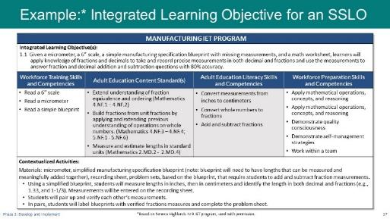
Present:
- Review the sample on the slide and discuss key points.
- The work you put into developing the SSLO and identifying the supporting skills and competencies in the three required components, as well as relevant adult education content standards, will help you develop contextualized lessons.
- Using our sample manufacturing IET program, let’s look at some of the activities that have been developed to achieve the integrated learning objective and acquire the associated skills and competencies.
- Discuss the contextualized activities at the bottom of the table and ask if anyone has other ideas for activities.
- The contextualized activities listed at the bottom relate directly to the integrated learning objective and the associated skills and competencies and standards.
- Ask if there are any questions.
- Let’s pause for questions before we move into our next activity where you’ll put some of what we’ve discussed into practice.
NEXT SLIDE

Breakout Group Activity #2: Brainstorm contextualized activities
Presenter: [NAME]
Duration: 21 min. (total)
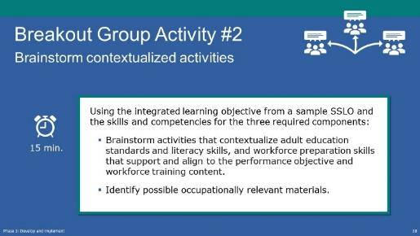
NOTE – IET Training Team:
- The breakout group assignments must be THE SAME as the previous breakout room activity.
- [If virtual] Have the technical assistant set up breakout rooms and assign participants and group facilitators to a room (See tech note below).
Present: (1 min.)
- Explain the activity.
- Now you’ll have the opportunity to practice developing contextualized activities to support learners in reaching the performance objective your group created in the last breakout session.
- As a group, you’ll brainstorm activities that contextualize occupational training skills, adult literacy skills, adult education standards, and workforce preparation skills that support and align to your objective from the SSLO.
- If you have time, discuss possible occupationally relevant materials.
- You’ll have 10 minutes to brainstorm your activities. (Shorten if behind on time, lengthen if time allows.)
- Your facilitator will take notes and share one idea on the topic.
NOTE – Technical Assistant:
- [If virtual] Assign participants to same breakout rooms as previous activity (add more as needed):
- Room 1 - [FACILITATOR(S) NAME(S)
- Room 2 - [FACILITATOR(S) NAME(S)
- Room 3 - [FACILITATOR(S) NAME(S)
Breakout Group Activity: (15 min.)
- FACILITATORS: Guide the discussion for the activity and take notes.
- Using the integrated performance objective from a sample SSLO, brainstorm activities that contextualize adult literacy skills, Adult Education Standards and workforce preparation skills that support and align to the objective and training content objectives.
- If time allows, identify possible occupationally relevant materials.
- [If in person] Use 3.B1_Develop_Implement_Breakouts_1-2_Facilitator_Guide.docx to capture your group’s activities. Alternatively, you may want to do this as a group brainstorming activity using large post-it paper. Group members can connect to others’ suggestions as they spark ideas. Then use the words on that sheet to develop the contextualized activities.
- [If virtual] Facilitators, instructions for facilitating this activity are in 3.B1_Develop_Implement_Breakouts_1-2_Facilitator_Guide.docx. Open the PowerPoint file, 3.B2_Develop_Implement_Breakouts_1-2_Facilitator _PPT_Virtual.pptx and share your screen. Capture your group’s activities directly on the slide.
Activity Debrief (5 min.)
- As time allows, call on a few group facilitators to briefly share their group’s activities and any insights from the discussion.
- [If virtual] Have facilitators copy and paste their group’s contextualized activities into the chat window once back on the main room.
NEXT SLIDE

3-3 Implement the IET Program and Collect Data
Start Time: [ENTER TIME]

Implement the IET Program and Collect Data – Topic Introduction
Presenter: [NAME]
Duration: .5 min.
Present:
- Introduce the topic and subtopics:
- Once you’ve developed your curricula and provided the necessary professional development to staff, it’s time to implement your IET program.
- In this section we’ll identify where we are in the continuous improvement process and then we’ll briefly talk about collecting data to support and inform decisions about continuous improvement as you launch the program and deliver the instruction.
NEXT SLIDE

Launching the IET Program and Delivering Instructional Content
Presenter: [NAME]
Duration: 1.5 min.
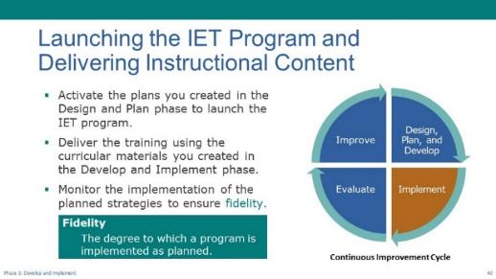
Present:
- Remind participants about the Continuous Improvement Cycle, tailoring the talking points to your training goals and plans for learning and collaboration over time.
- You’re now in the Implement stage of the continuous improvement cycle.
- This is where you’ll activate all those plans you created during the Design and Plan phase and launch the IET program.
- You’ll deliver the instructional content using the contextualized curricular materials you created in the Develop and Implement phase.
- Throughout this phase, you’ll monitor the implementation of the program’s planned strategies and activities to ensure the program is being implemented as planned, or with fidelity. Any changes in strategies should be made only after first implementing them with fidelity. Then, if data from the evaluation shows that the strategies aren’t as effective as expected, changes can be made based on the data
- Part of monitoring is collecting data, which we’ll discuss next.
- We know this makes it sound simple, and we recognize that it’s not. The IET Toolkit and resources are intended to provide guidance as you implement the program, but true continuous improvement requires time and attention and learning through trial and error. We’re going to talk more about continuous improvement in the next phase.
NEXT SLIDE

Collecting Data to Support and Inform Decisions
Presenter: [NAME]
Duration: 1 min.
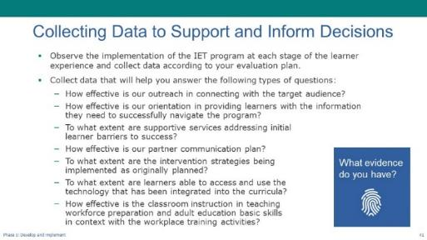
Present:
- Use the PPT slide to discuss collecting data throughout implementation.
- It’s important to collect data as you’re implementing the program. This will allow you to identify and understand your successes and challenges and connect what you learn to your evaluation plan.
- The data you collect should help you answer the types of questions on the slide.
- Read a few of the questions.
- For each of your answers to these questions, you should be able to explain how you know this to be true. In other words, what evidence do you have to support your response? For example, evidence for the last bullet might be the results of your performance assessments.
- In the Evaluate and Improve phase, you’ll use the data you collect to support and inform your decisions by identifying successes and gaps that need to be addressed.
- Again, we’ll be talking about the evaluation plan in our next session.
NEXT SLIDE

3-4 Wrap-Up
Start Time: [ENTER TIME]

Wrap-Up - Topic Intro
Presenter: [NAME]
Duration: 1 min.
Present:
- Explain that we will wrap up the session as always by:
- Reviewing some key takeaways from this session.
- Reflecting on what you learned, what stood out to you, and what questions you may have.
- Conducting a quick poll.
- Reviewing next steps.
NEXT SLIDE

5 Key Takeaways
Presenter: [NAME]
Duration: 2 min.
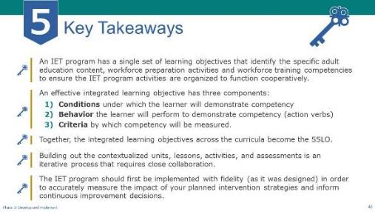
NOTE – Technical Assistant:
- This slide has 4 builds/clicks to display the key takeaways one a time as the facilitator discusses each (see below).
Present:
- Review key takeaways.
- An IET program has a single set of learning objectives that identify the specific adult education content, workforce preparation activities and workforce training competencies to ensure the IET program activities are organized to function cooperatively.
- An effective integrated learning objective has three elements:
- The conditions under which the learner will demonstrate competency
- The behavior the learner will perform to demonstrate competency (using action verbs)
- The criteria by which competency will be measured.
- Together, the integrated learning objectives across the curricula become the SSLO.
- Building out the contextualized units, lessons, and activities is an iterative process that requires close collaboration between training partners.
- And the last key takeaway – To accurately measure the impact of your planned intervention strategies and inform continuous improvement decisions, the IET program should first be implemented with fidelity (as it was designed) to the greatest extent possible. Then, if data from the evaluation shows that the strategies aren’t as effective as expected, changes can be made based on the data.
NEXT SLIDE

Group Discussion: Reflection (Optional)
Presenter: [NAME]
Duration: 10 min.
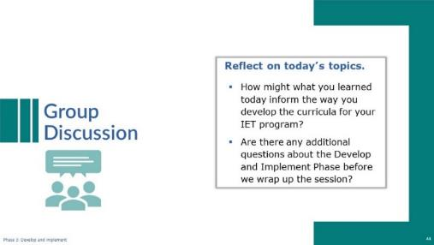

NOTE – IET Training Team:
- This is an optional discussion that can be conducted with the whole group of participants, or you may choose to conduct it in breakout groups and then ask groups to share one or two things they came up with.
Discuss:
- Lead a group discussion reflecting on the concepts and processes covered in this session.
Possible questions include:
- How might what you learned today inform the way you develop the curricula for your IET program?
- Are there any additional questions about the Develop and Implement Phase before we wrap up the session?
NEXT SLIDE

Poll: Confidence Level (Optional)
Presenter: [NAME]
Duration: 2 min.
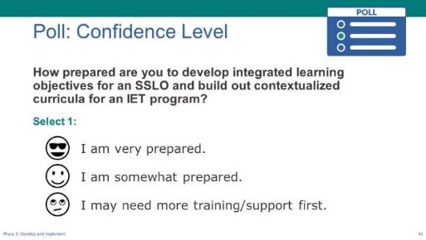
NOTE – IET Training Team:
- This is an optional poll. You can choose to delete or modify it as needed. Remember to do the same in the slide deck.
Poll:
- Introduce the poll question and ask participants to respond.
- How prepared are you to develop integrated learning objectives for an SSLO and build out contextualized curricula for an IET program?
- I feel very prepared.
- I feel somewhat prepared.
- I may need more training/support first.
- If you are delivering the training in-person, read the options and have participants raise their hands (“Raise your hand if you feel very prepared.” “Who feels somewhat prepared?” “Raise your hand if you feel you may need more training or support first?”).
- If virtual, ask technical assistant to launch poll and give participants a little time to respond, then share the results.
NEXT SLIDE

Next Steps
Presenter: [NAME]
Duration: 2 min.
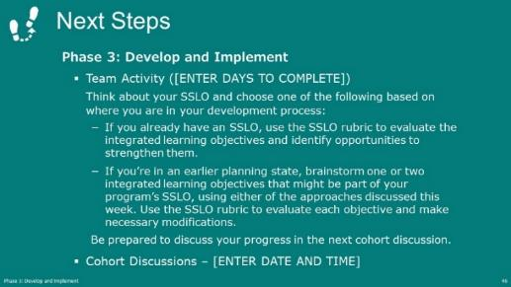
NOTE – IET Training Team:
- Modify this slide and the next to reflect your structure and schedule. For example, add dates and times where indicated. If you are not doing cohorts, remove the last bullet on this slide.
Present:
- Use the PPT slide to talk through the team activity and the next cohort meeting (if applicable).
NEXT SLIDE

Next Steps (cont.)
Presenter: [NAME]
Duration: 1 min.
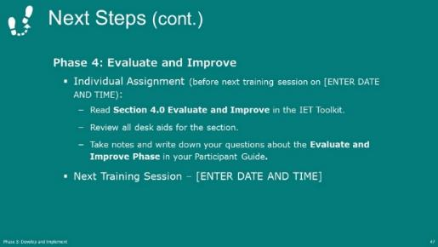
NOTE – IET Training Team:
- Modify this slide to reflect your structure and schedule. Add dates and times where indicated.
Present:
- Explain the individual assignment to do before the next session and restate the date and time of the next session (if applicable).
- Thank everyone for their participation and end session.

After the Session

Follow-Up Recommendations
- Send an email to check in with participants before the next training session.
- Remind them of the homework assignment, the date and time of the cohort meeting (if applicable), and the date and time of the next Design Camp training session.
- Suggest that participants review the Evaluate and Improve section of the IET Toolkit, including any desk aids and tools.
- Remind participants to write down any questions they have in their Participant Guide as they review the Evaluate and Improve section and bring them to the next training session.

