IET Design Camp Phase 2: Design and Plan
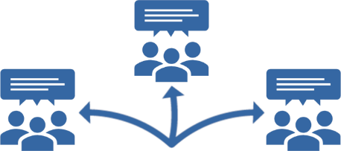

Breakout Group Activity #2

What does a successful IET learner experience look like?
15 minutes

Facilitator Instructions:
- Work with the breakout group members to come up with key considerations for the IET program based on the learner profile in Appendix B, #B1 of the Participant Guide.
SAY:
Put yourselves in the shoes of the learner in the profile and discuss a simulated walkthrough of the IET experience. You’ll create a list of key considerations from the perspective of the learner and some potential learner supports to address them.
- Once you have identified some considerations, have group members brainstorm potential learner supports to address the considerations.
- Capture the group’s ideas.
  - If in-person: Use the next page of this handout to capture the information.
  - If virtual: Open the 2.B4_Design_Plan_Breakout_2_Facilitator_PPT_Virtual.pptx and share your screen. Capture the group’s ideas directly on the slide as they work through the activity.
- You will share one key consideration and one potential learner support to address it with the larger group during the activity debrief.
- [If virtual] Copy and paste the group’s lists of key considerations and potential learner supports into the chat window once you are back in the main room.

Examples of Key Considerations:

- Get to work quickly
- Need supportive services (e.g., financial aid for tuition, books, expenses)
- Varied interests (gardening, entrepreneurship, nursing)
- Previous work experience in gardening

Examples of Potential Learner Supports:

- Career navigator
- Evidence-based reading instruction
- Interest and transferrable skills inventory
- Bring employers into the classroom

Key Considerations
- Blank area to write considerations
- Blank area to write learner supports
- Blank area to write learner supports
- Blank area to write learner supports
- Blank area to write learner supports
- Blank area to write learner supports
- Blank area to write learner supports
- Blank area to write learner supports
- Blank area to write learner supports
- Blank area to write learner supports

Potential Learner Supports
- Blank area to write learner supports
- Blank area to write learner supports
- Blank area to write learner supports
- Blank area to write learner supports
- Blank area to write learner supports
- Blank area to write learner supports
- Blank area to write learner supports
- Blank area to write learner supports
- Blank area to write learner supports
- Blank area to write learner supports

