Facilitator Guide for IET Design Camp
ORIENTATION

Facilitator Guide for IET Design Camp
Orientation

Introduction
Welcome to the Facilitator Guide for the virtual or in-person delivery the IET Design Camp Orientation. This guide outlines everything you need to know to facilitate the training, including session logistics, training materials, learning objectives, timing, and talking points for each slide. Training teams should a) review this guide and the corresponding training materials (see below) and b) make modifications based on who is delivering the training, when s/he will deliver the training, and how s/he will deliver the training.

Logistics
Date: [ENTER DATE]
Time: [ENTER TIME AND TIME ZONE]
Estimated Run Time: 2 hours [EDIT ESTIMATED TIME AFTER CUSTOMIZING SLIDES]
Technical Assistant: [ENTER TECHNICAL ASSISTANT NAME]
Moderator(s): [ENTER MODERATOR NAME(S)]
Trainers/Facilitators: [ENTER TRAINER/FACILITATOR NAME(S)]

Overview
This orientation will provide participants of the IET Design Camp with an overview of the Design Camp, including logistics, format, schedule, and expectations for the training series. In addition, Design Camp trainer(s) will provide an overview of integrated education and training (IET) programs, including Workforce Innovation and Opportunity Act (WIOA) requirements. Finally, participants will take a brief tour of the IET Toolkit and its desk aids and tools, some of which they will use in various activities throughout the Design Camp.

Training Materials
- PowerPoint Deck: 0.A2_Orientation_PPT.pptx
- Participant Guide: Participant_Guide.docx
- Breakout Group Activity Files:
- (In-person)
0.B3_Orientation_Breakout_1_Participant_Handout_In-Person.docx
- (Virtual)
0.B1_Orientation_Breakout_1_Facilitator_Instructions_Virtual.docx
0.B2_Orientation_Breakout_1_Facilitator_PPT_Virtual.pptx

Objectives
After completing this session, participants will be able to:
- Describe [INSERT STATE]’s vision and goals for IET and how this training supports that vision.
- Identify the required components and key characteristics of an IET.
- Describe the overall structure of the Design Camp.
- Describe the use of cohorts (if applicable).
- Access the IET Toolkit and its key resources.

0-0 Overview/Introduction
Start Time: [Enter Time]

Welcome and Introduction to the IET Design Camp
Presenter: [NAME]
Duration: 2 min.
Present:
- Welcome participants to the session and thank them for participating in the Design Camp.
- Introduce yourself and talk about the IET Design Camp briefly.
- We’re all here today because we’re committed to ensuring that ALL adults have access to and succeed in programs that develop the skills they need to survive, thrive, and strive in their families, communities, and jobs. Integrated Education and Training programs—programs that are intentionally designed to balance and integrate adult education and literacy, workforce preparation, and workforce training—are a proven approach to helping adults build skills while preparing them to succeed in work and further education.
- The materials we are using for this training were initiated through a technical assistance effort supported by the U.S. Department of Education, Office of Career, Technical and Adult Education, or OCTAE. The IET Design Camp is designed to provide resources and skills to help you design and deliver high quality IET programs.
- This will be hands-on learning. We recognize that some of you are bringing significant experience with IETs to our Design Camp, and all of you have important and broad adult education experience that will inform our work together. Throughout the Design Camp, you’ll have many opportunities for dialog with your peers and the training team so you can learn from each other.
- Please have your questions and notes from your reading assignment ready as we dive into today’s session.
- We’re looking forward to sharing this journey with you, so let’s get started!
- NEXT SLIDE

Virtual Meeting Recording Notice (OPTIONAL)
Presenter: [NAME]
Duration: 1 min.
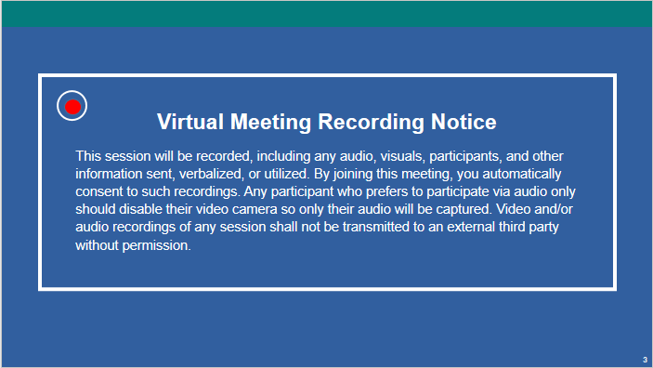
NOTE – IET Design Team:
- This is an optional slide. If you are delivering the training in person or do not need a recording notice, delete this slide from the PowerPoint slide deck and from this Facilitator Guide.
Present:
- Inform participants that this session will be recorded and direct them to the disclosure on the slide.
- NEXT SLIDE

Your Design Camp Trainers
Presenter: [NAME]
Duration: 5 min.
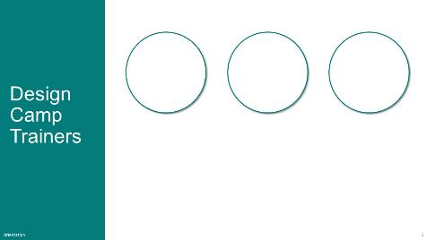
Present:
- Introduce the trainers or have them introduce themselves.
- NEXT SLIDE

Agenda
Presenter: [NAME]
Duration: 1 min.
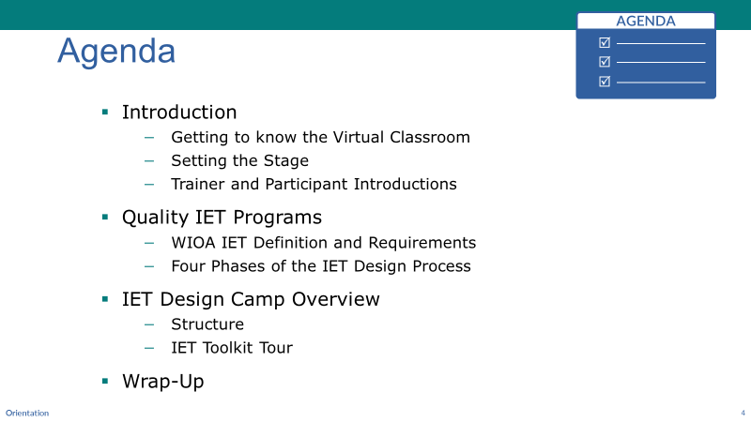
NOTE – IET Training Team:
- If you are delivering the training in-person, remove the second sub-bullet below.
Present:
- Review the agenda
- This Orientation to the IET Design Camp will be about two hours [EDIT ESTIMATE ONCE YOU HAVE GONE THROUGH AND DECIDED WHICH SLIDES TO KEEP].
- We’ll start by going over a few tips for getting the most out of our learning platform before we get into the content of IETs.
- We’ll hear from [INSERT SPEAKER INFORMATION], who will share some information about the reason we’re focusing on IET programs to help adults build skills while preparing them to succeed in work and further education, and to help build a skilled workforce for local employers, which will support economic growth of the nation.
- Next, we’ll introduce our training team.
- Then we’ll spend some time talking about quality IET programs to set the foundation for the Design Camp. Specifically, we’ll review the definition and requirements for IET from the Workforce Innovation and Opportunity Act (WIOA) so that we all have the same reference when talking about what constitutes an IET and what doesn’t.
- The Design Camp is organized around the four phases of the IET design process, which we’ll briefly touch on today.
- Finally, we’ll provide an overview of the Design Camp before wrapping up with next steps.
- Transition to NEXT SLIDE.
- [If Virtual] Our plan today, and throughout our time together, is to take advantage of polling, the chat feature and breakout rooms, so, let’s take a quick minute to peek at this platform.
- [If In-Person] Introduce the person who will speak to the next few slides about the value of IET programs.
- NEXT SLIDE

Getting Familiar with the Virtual Classroom (OPTIONAL)
Presenter: [NAME]
Duration: 1 min.
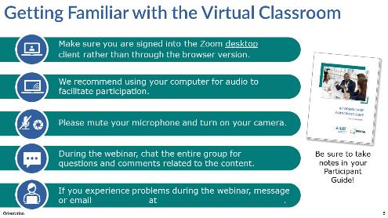
NOTE – IET Training Team:
- This is an optional slide. If you are delivering the training in person, delete this slide from the PowerPoint slide deck and from this Facilitator Guide. If you are delivering the training in another platform, edit this slide accordingly.
Present:
- Next, we want to provide a few key tips and tricks to get the most out of our virtual sessions:
- Hopefully you’re using the Zoom desktop app and not the browser version, as the desktop is more reliable.
- We encourage you to turn your camera on, especially if you’re speaking and in breakout rooms. However, if you have bandwidth issues, you may want to keep your camera off to improve quality. And please mute your microphone when not speaking so that we can avoid distracting background noise.
- Throughout the webinar, we encourage you to use the chat window to ask or answer questions, make comments, or share resources with the group.
- If you have any technical issues during the session, reach out to [TECHNICAL ASSISTANT NAME] either via private chat or email.
- NEXT SLIDE

Focus on IET Programs (OPTIONAL)
Presenter: [NAME]
Duration: 2 min.
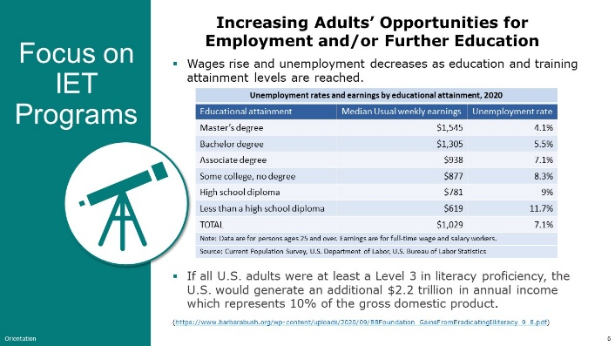
NOTE – IET Training Team:
- This is an optional slide. You can use it as-is or tailor it to your state.
Present:
- Explain why IET and adult education are important in your state. Tailor the remarks to your environment.
- Adult education has always been about providing access and opportunity for adults to develop the skills they need to survive, thrive, and strive in their families, communities, and jobs.
- Through the contextualization of basic skills with both employability and occupational skills, IETs support an adult’s movement along a career pathway to accelerate the time it takes for them to enter employment or further education and training. The case for investing in adult education plays out at both the individual and the community levels. For individuals, skill and education attainment gives them a better chance at higher wages and lowers the likelihood of facing unemployment. At the same time, research has shown that improving literacy could improve our nation’s overall productivity and have a positive impact of workforce inequities.
- [INSERT EXAMPLES from the State and County Skills map available at https://nces.ed.gov/surveys/piaac/state-county-estimates.asp#4].
- [INSERT EXAMPLES on numbers of individuals served through adult education programs and/or the strategic priorities in place for your state.]
- As the economy changes, the work we are doing in adult education in [INSERT STATE] has been focused on bringing foundational skill building together within occupational contexts. We have been working to support ALL adult learners with transitions to careers and are using IETs to do that.
- [INSERT EXAMPLES from across your state on progress, challenges, success.]
- NEXT SLIDE

IET Programs Revolutionize Career and Education Pathways for Adult Learners (Optional)
Presenter: [NAME]
Duration: 2 min.
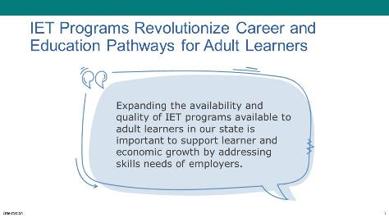
NOTE – IET Training Team:
- This is an optional slide. You can use it as-is or tailor it to your state. Focus on the “why” aspect of your state’s focus on IET.
Present:
- Discuss how IET programs are different and require new ways of working to support student success. Tailor the slide and remarks to your state. [INSERT rationale from state for focus on IET.]
- [INSERT recognition that IETs may require new ways of doing things for some of your participants, i.e., adult education working with workforce and/or CTE partners, engaging businesses in their communities, conducting research to assess the need for an IET, etc.]
- NEXT SLIDE

Enrollment Trends in IET Programs (Optional)
Presenter: [NAME]
Duration: 2 min.
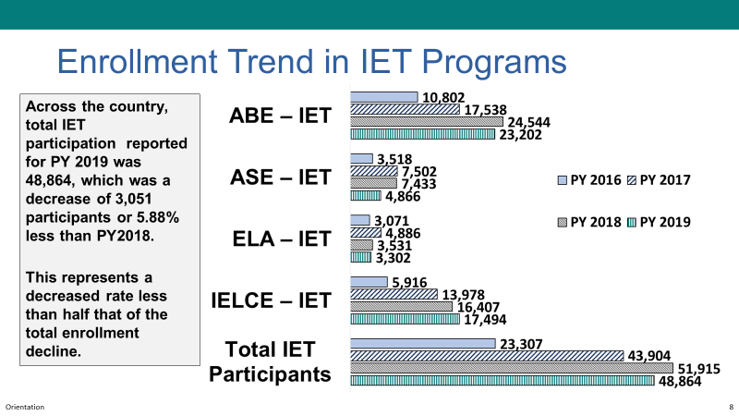
NOTE – IET Training Team:
- This is an optional slide. You can use it as-is to focus on the national numbers or tailor it to your state, i.e., Where are we now? Where do we want to go?
Present:
- Discuss your state’s data on IET participation.
- This slide shows you what’s going on with IET enrollment trends in [INSERT STATE].
- [INSERT information on goals and priorities to increase enrollment, focus on quality at the current level, etc.]
- NEXT SLIDE

Our Charge to You (Optional)
Presenter: [NAME]
Duration: 1 min.
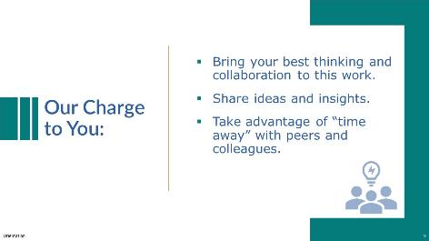
NOTE – IET Training Team:
- This is an optional slide. Tailor the message to the state's expectations for training participants.
Present:
- Share the state’s expectations for training participants.
- A key characteristic of IET programs is that they are intentionally designed. All effective design work is iterative and collaborative. Our first idea is rarely our best one, and our ideas are strengthened through input from others.
- This Design Camp is also intentionally designed, and we look to you to engage within and across your state and local teams. So, we invite you to take advantage of the time together. Bring your best thinking to the Design Camp and share your insights and ideas, as well as your challenges.
- We have much to learn from one another, so let’s try to unplug from our other responsibilities while we participate in this training and explore opportunities to leverage ideas and experiences.
- NEXT SLIDE

Breakout Group Meet and Greet (Optional)
Presenter: [NAME]
Duration: 16 min. (total)
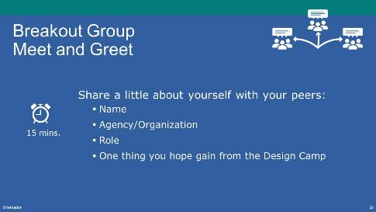
NOTE – IET Training Team:
- This is an optional icebreaker. If you are having cohorts in your Design Camp, you may want to assign participants to a breakout group of their cohort peers.
- Delete or modify the slide as needed. Remember to do the same in the slide deck.
Present: (1 min.)
- Explain the activity.
- We’re going to spend a bit of time in breakout groups so you can meet some of your peers and briefly share who you are, what your role is, and what you hope to gain from the training.
- When we come back to the main room, we’ll dive into the Orientation.
NOTE – Technical Assistant:
- If virtual, assign participants to breakout rooms as needed:
- Room 1- [FACILITATOR(S) NAME(S)]
- Room 2- [FACILITATOR(S) NAME(S)]
- Room 3- [FACILITATOR(S) NAME(S)]
Breakout Group Meet and Greet: (15 min.)
- Facilitate brief introductions (name, role, one thing they hope to get out of the Design Camp).

0-1 Quality IET Programs
Estimated Start Time: [ENTER TIME]

Quality IET Programs- Topic Intro
Presenter: [NAME]
Duration: 1 min.
Present:
- Introduce the topic and subtopics.
- Before we dive into the Design Camp further, we want to make sure to set a firm foundation that defines quality IET programs.
- We’ll talk a bit about the required components of an IET and spend some time in breakouts to explore examples of programs and whether they meet those requirements. We’ll also talk a bit about the IET design process and guiding principles to keep in mind during that process.
- NEXT SLIDE

Poll: Participation in IET (Optional)
Presenter: [NAME]
Duration: 2 min.
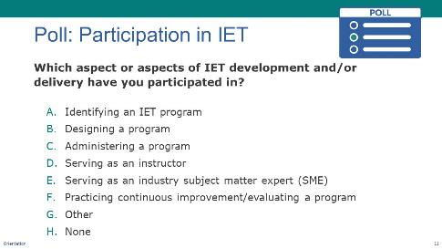
NOTE – IET Training Team:
- This is an optional poll designed to engage participants and to give the trainers a feel for who the participants are and what their experience level is with IETs. You can delete or modify it as needed.
Poll:
- Introduce the poll question and ask participants to respond.
- If you are delivering the training in-person, read the options and have participants raise their hands.
- If virtual, launch poll and give participants a little time to respond, then ask technical assistant to share the results.
- Respond to the results
- NEXT SLIDE

Group Discussion: What is IET?
Presenter: [NAME]
Duration: 4 min.
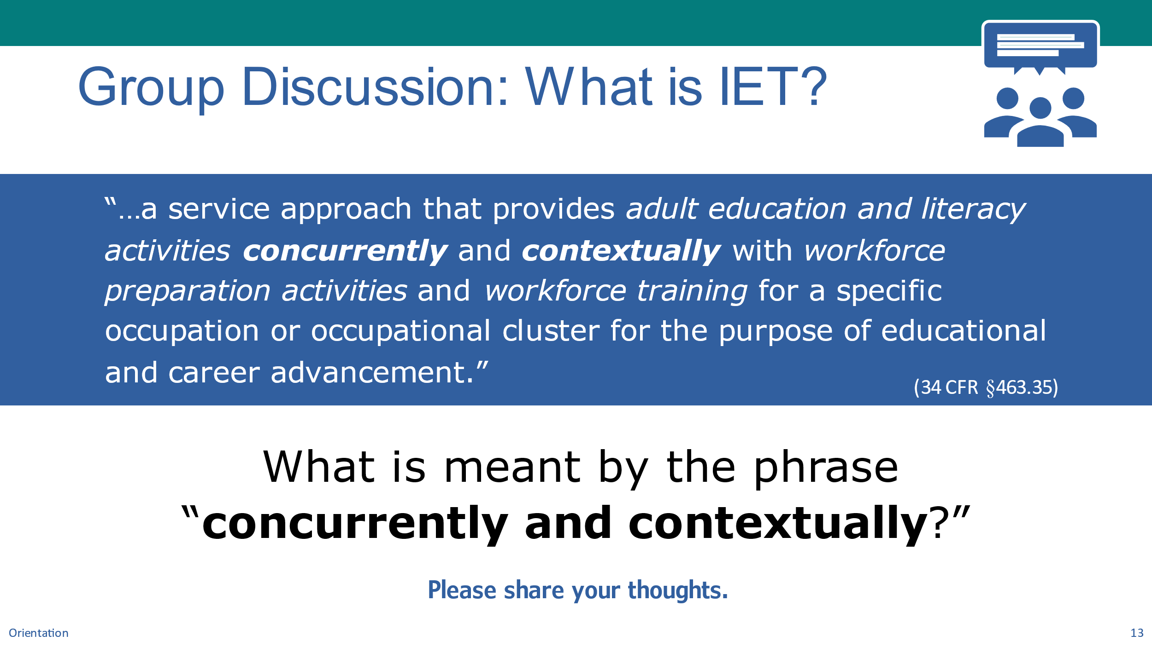
NOTE – Technical Assistant:
- This slide has one build/click.
- When asked, click to display the chat/discussion question.
Present (1 min):
- Review the definition of an IET program.
- Let’s begin by reviewing the definition of an IET program from the WIOA regulations found at 34 CFR §463.35.
- “…a service approach that provides adult education and literacy activities concurrently and contextually with workforce preparation activities and workforce training for a specific occupation or occupational cluster for the purpose of educational and career advancement.”
- There’s a lot to unpack here beginning with the basics that the IET program:
- Must integrate the delivery of the three required components for a specific occupation or occupational cluster:
- adult education and literacy activities,
- workforce preparation activities, and
- workforce training activities.
- Must be part of a career pathway and that leads to educational and career advancement and is aligned with the state’s Adult Education Content Standards.
- It’s important to note that the definition is clear that the adult education and literacy activities must be provided concurrently with the other two components and the instruction must be contextualized within the specific occupational cluster.
CLICK TO DISPLAY DISCUSSION QUESTION
Chat/Discuss: (2.5 min)
- Introduce the discussion question and ask participants to share ideas.
- Let’s take a moment to share what “concurrently and contextually means” to you.
- (Virtual) Please share your ideas in the chat.
- (In-Person) Ask participants raise their hand or call out responses.
- Respond to answers.
- NEXT SLIDE

IET Component Integration
Presenter: [NAME]
Duration: 4 min.
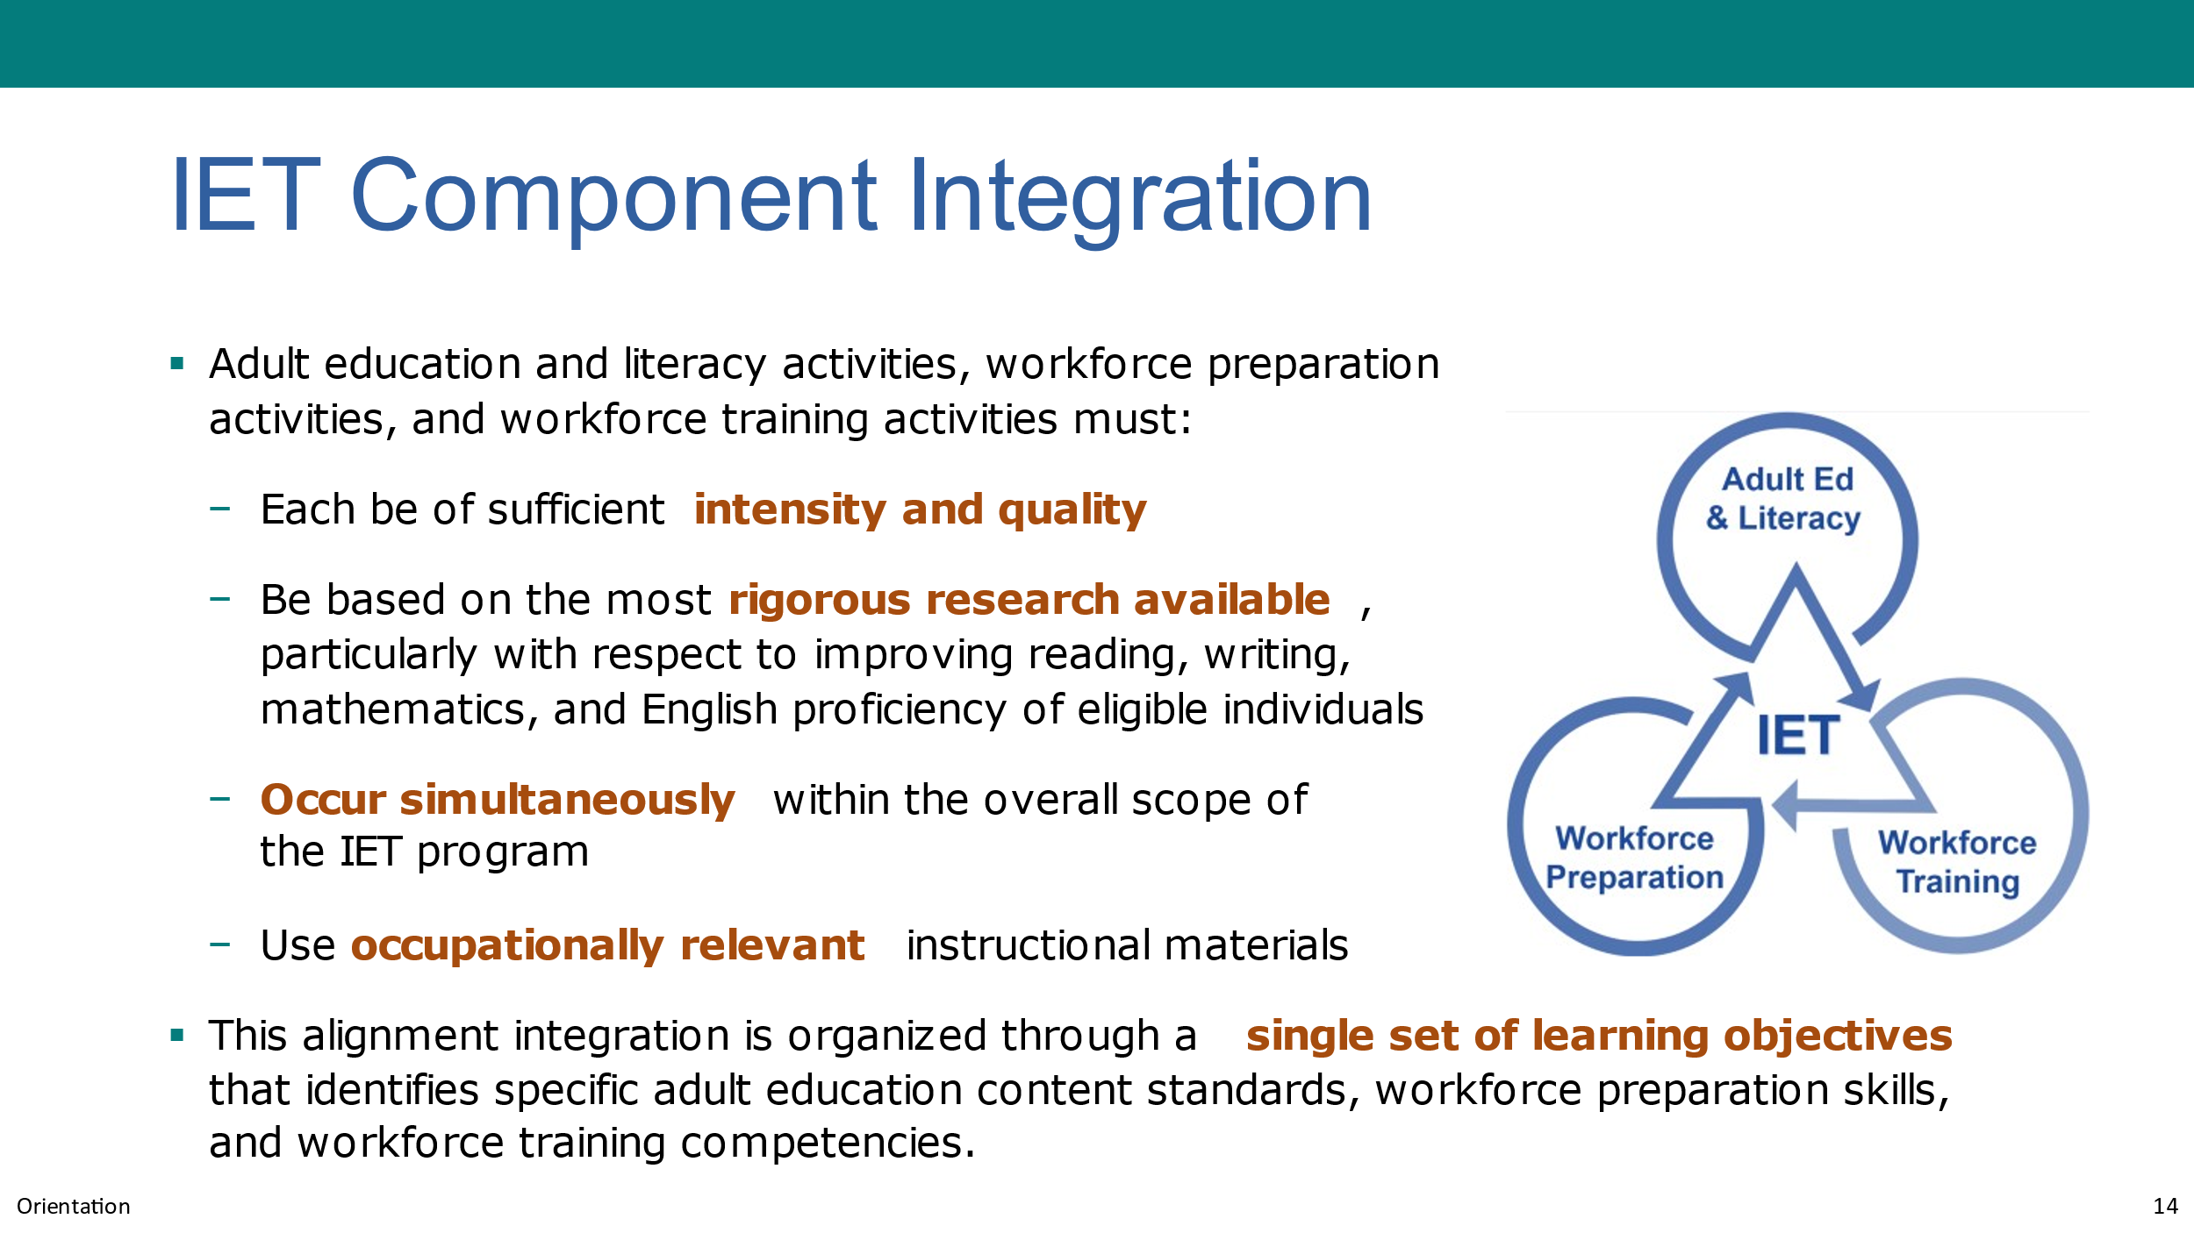
NOTE – IET Training Team:
- This slide and the next may be a good time to share any state-specific guidance or requirements for IET programs. Consider developing new slide(s) or facilitating a discussion around state-specific guidance.
NOTE – Technical Assistant:
- This slide has one build/click.
- When asked, click to display the last bullet.
Present:
- Explain the components of an IET.
- Let’s breakdown the components of an IET beginning with the adult education and literacy (AEL) activities, which I’m sure are the most familiar to you all. You can review the regulations at 34 CFR §463.37.
- What are Adult Education and Literacy Activities?
- WIOA defines “adult education and literacy activities” as “programs, activities, and services that include: (a) adult education, (b) literacy, (c) workplace adult education and literacy activities, (d) family literacy activities, (e) English language acquisition activities, (f) integrated English literacy and civics education, (g) workforce preparation activities, or (h) integrated education and training.”
- What are Workforce Preparation Activities?
- Workforce preparation activities go way beyond teaching someone how to interview, develop a resume, or dress for success. The workforce preparation activities outline the skills needed to be successful on the job or in other post-secondary education and training opportunities. Activities, programs, or services like critical thinking skills, digital literacy skills, and self-management skills, including competencies in the following: (a) utilizing resources; (b) using information; (c) working with others; (d) understanding systems; (e) skills necessary for successful transition into and completion of postsecondary education or training, or employment; and (f) other employability skills that increase an individual's preparation for the workforce.
- What is Occupational Training?
- The third required component is occupational training for the specific occupational skills learners need to be employed for a particular job or cluster of jobs. Workforce training may be the following:
- In-classroom or online occupational skills training
- On-the-job training
- Incumbent worker training
- Programs that combine workplace training with related instruction, like apprenticeship
- Training programs operated by the private sector
- Entrepreneurial training
- WIOA requires that each component of an IET program must be of sufficient intensity and quality.
- One way to ensure sufficient quality is to base it on the most rigorous research available, particularly with respect to improving reading, writing, mathematics, and English proficiency of eligible individuals.
- Additionally, as you design your IET program, remember that the elements of an IET program must be provided concurrently and contextually, meaning that the adult education and literacy activities, workforce preparation activities, and workforce training activities simultaneously occur within the overall scope of the IET program and use occupationally relevant instructional materials to contextualize the adult education and literacy standards being taught.
CLICK TO DISPLAY LAST BULLET
- One of the key requirements for an IET program is that the program must be designed around a single set of integrated learning objectives that identify specific adult education content standards, workforce preparation skills, and workforce training competencies. We’ll be talking more about the single set of learning objectives later in the training series.
- NEXT SLIDE

Educational and Career Advancement
Presenter: [NAME]
Duration: 1 min.
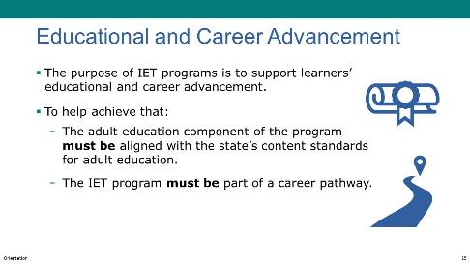
Present:
- Discuss the role of IET programs in educational and career advancement.
- While we’ve been delving into the ‘what and how’ of IET programs, we never want to lose sight of the “why.” These programs are so powerful because they support learners’ educational and career advancement and accelerate the time it takes for them to take the next step—whether that means further training or entering employment.
- To help ensure that IETs do that, the WIOA regulations require that the adult education component aligns with the state’s adult education content standards and the IET program fits within a workforce system clearly articulated career pathway.
- NEXT SLIDE

Breakout Group Activity #1: Is it an IET?
Presenter: [NAME]
Duration: 21 min. (total)
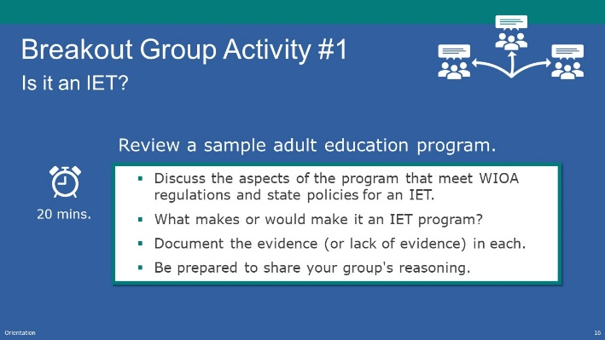
NOTE – IET Training Team:
- If you are conducting the training in person, this activity can be conducted in small groups, with or without a group facilitator.
- If you are conducting the training virtually, you will need to have the technical assistant set up breakout rooms and assign participants and group facilitators to a room (See tech note below).
- Assign each small group one of the sample adult education programs from the participant guide before this activity.
Present: (1 min.)
- Explain the activity.
- First, take a couple of minutes to meet your colleagues in the group – briefly sharing your name and your experience level with developing IET programs.
- Your task is to read the short narrative of the program assigned to your group and look for evidence for the program being an IET program as defined in WIOA.
- You’ll have about 20 minutes total (including introductions).
NOTE – Technical Assistant:
- Assign participants to breakout rooms as needed:
- Room 1- [FACILITATOR(S) NAME(S)
- Room 2- [FACILITATOR(S) NAME(S)
- Room 3- [FACILITATOR(S) NAME(S)
Breakout Group Activity: (20 min.)
- Direct participants to Appendix A of their Participant Guide.
- Assign a program example to each group.
- If In-Person: Distribute the 0.B3_Orientation_Breakout_1_Participant_Handout_In-Person.docx (one per group).
- If Virtual: Facilitators, instructions for facilitating this activity are in 0.B1_Orientation_Breakout_1_Facilitator_Instructions_Virtual.docx. Using the screenshare feature, share the program example assigned to your group from 0.B2_Orientation_Breakout_1_Facilitator_PPT_Virtual.pptx. (mention that it is also in Appendix A of their Participant Guide).
- Have participants quickly review the program example, then discuss the evidence that of the components of an IET program.
- Note that the Medical Records example does not have many clear features of being an IET per the definitional requirements. Facilitate a discussion about what can be changed to make it an IET. All other examples have compelling evidence but leave room for interpretation or disagreement and have elements that could be added to make them clearly IETs as defined in the legislation
- Also note, the state may have requirements beyond the federal requirements that you may wish to use this activity as a springboard to discuss.

Activity Discussion: Is it an IET?
Presenter: [NAME]
Duration: 5 min.
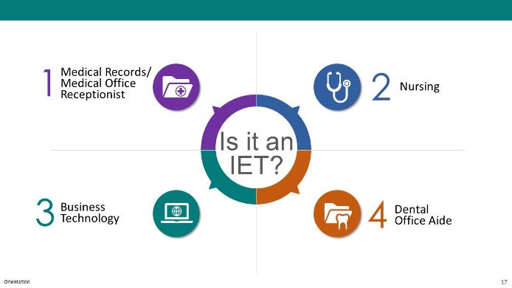
NOTE – Technical Assistant:
- This slide has an animation that requires several clicks.
- Click to display each IET program as it is discussed.
Present:
- Review each program example one at a time and discuss the participants’ decisions and ideas.
- Medical Records: Groups may decide that this is not an IET. 1) No evidence of workforce preparation skills offered concurrently-they appear to be after the class ends 2) No evidence of concurrent adult education appears to be offered prior to the training program.
- Business Technology: Groups may decide that this is an IET. 1) All three components are offered concurrently 2) Joint planning with curriculum development.
- Nursing: Groups may decide that this is an IET. 1) All three components are offered concurrently 2) Occupationally relevant materials are used 3) Part of a career pathway.
- Dental Office Aide: Groups may decide that this is an IET. 1) Adult education is provided contextually 2) Workforce preparation skills are taught throughout the IET 3) Adult basic education is taught concurrently 4) Part of a career pathway.
- NEXT SLIDE

The IET Program Design Process
Presenter: [NAME]
Duration: 2 min.
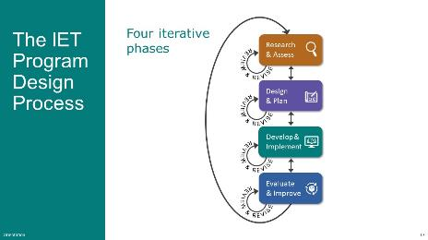
Present:
- Use the slide to describe the IET program design process.
- The IET program design process is an iterative one that can be broken into four phases—each of which is also iterative.
- In Phase 1, Research and Assess, the process begins with identifying an IET opportunity that meets community needs. In the Toolkit and in this training, we’ll outline a strategic process to assess regional workforce development, adult learner needs, and available resources, including potential training providers. We’ll also pull out key insights from what you learn and identify an IET program opportunity that meets those needs.
- In Phase 2, Design and Plan, you’ll review an organized design process to identify program goals, create an evaluation plan, and design a learner experience that addresses the needs of businesses and adult learners. The IET Planning Tool helps you document your design work.
- In Phase 3, Develop and Implement, you’ll develop integrated learning objectives, build contextualized instructional and training materials, and launch your IET program. You’ll also collect data according to your evaluation plan.
- In Phase 4, Evaluate and Improve, you’ll observe the implementation of the IET program, analyze data gathered to determine the effectiveness of the program in meeting community and learner needs, and make improvements as needed. This section of the training also includes information to help prepare for more formal evaluations.
- NEXT SLIDE

3 Guiding Principles of IET Program Design
Presenter: [NAME]
Duration: 2 min.
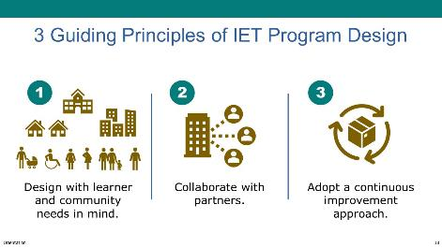
Present:
- Review the three guiding principles of IET program design.
- As OCTAE and the developers of the IET Design Camp materials listened to practitioners talk about their IET program design work, three key themes stood out to them. They can be described as guiding principles for quality IET program design, and they’ve been woven into the Toolkit and the Design Camp itself.
- The first is to design with learner and community needs in mind. Putting these needs at the center of program selection and design work helps ensure that programs are relevant, effective, and successful in helping a diverse population of learners advance in their careers and education. Having a designer's mindset of creativity, adaptability, and innovation helps here too.
- The Second is to collaborate with partners. The work of integrating education and training and supporting learner’ successful transition into work or further education can’t be done by adult educators alone. You need collaborative education and workforce development partners.
- The third is to adopt an approach of continuous improvement. Business and learner needs are continually shifting, resulting in a need for new evidence-based practices. IET programs use available program data to test new approaches, capture lessons learned, and build on successful elements of your IET program to support continuous improvement and adapt to changing needs.
- NEXT SLIDE

Questions? (Quality IET Programs)
Presenter: [NAME]
Duration: 4 min.
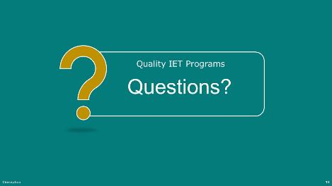
Present:
- Ask if there are any questions about what constitutes a quality IET program.
- NEXT SLIDE

0-2 IET Design Camp Overview
Estimated Start Time: [ENTER TIME]

IET Design Camp Overview - Topic Intro
Presenter: [NAME]
Duration: 1 min.
Present:
- Introduce the topic and subtopics.
- What is the IET Design Camp?
- Design Camp Structure
- Materials and Where to Find Them
- Cohort Training Format (if applicable)
- Expectations – Yours and Ours
- NEXT SLIDE

What is the IET Design Camp?
Presenter: [NAME]
Duration: 2 min.
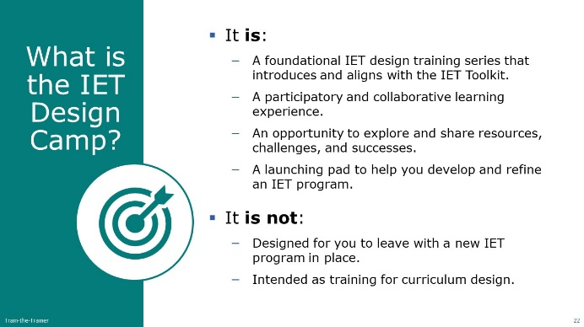
NOTE – Technical Assistant:
- This slide has one build/click (see below).
Present:
- Share features of the Design Camp—what it is and what it’s not:
- It is a foundational IET design training series that introduces and aligns with the IET Toolkit, which we’ll look at in just a minute. Both the Toolkit and the Design Camp guide you through the process of designing and developing customized IET solutions that address the needs of adult learners and local businesses.
- Each session is designed to be a participatory and collaborative learning experience, as well as an opportunity to explore and share resources, challenges, and successes so that we can all learn from each other.
- Think of this training series as a launching pad to help you design, develop, and refine IET programs that meet WIOA requirements of an IET, which we’ll also talk about.
[CLICK TO BUILD SLIDE]
- Now let’s talk about what the Design Camp is not.
- The Design Camp is not intended to ensure you leave here with a brand new IET program in place. We know that likely takes a bit more time than the time during which you participate in the Design Camp, and you can certainly use this time to take key actions beyond what we are asking of you in between sessions to make progress on new or existing IET programs.
- It’s also not a curriculum design training, though we will share some guiding principles and promising practices as it relates to designing curriculum for an IET program.
- NEXT SLIDE

Design Camp Structure
Presenter: [NAME]
Duration: 2 min.
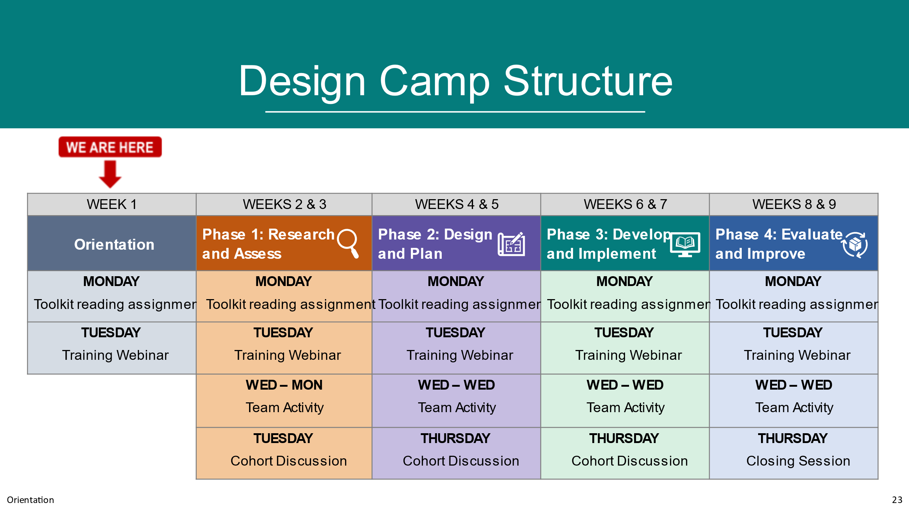
NOTE – IET Training Team:
- Modify the slide to reflect how you will be presenting the IET Design Camp and adjust the talking points below to align with your structure. The example depicts 9 weeks of training broken into five sessions. The first session is an orientation to the Design Camp. The remainder of the sessions cover the four phases of the IET design process with follow-up cohort discussions.
Present:
- Use the PPT slide to discuss the structure of the Design Camp and orient participants to where they are in the process (Orientation).
- NEXT SLIDE

Design Camp Materials
Presenter: [NAME]
Duration: 1 min.
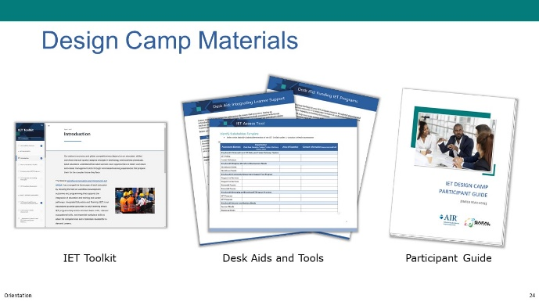
NOTE – Technical Assistant:
- This slide has 2 builds/clicks to display the Design Camp materials as the facilitator discusses each (see below).
Present:
- Describe the training materials.
- There are three types of materials that support you and your work in the Design Camp. The first is the IET Toolkit, which is available in an online interactive version as well as a PDF that you can download or print. We’re going to look at the Toolkit in a few minutes.
- The Toolkit walks you through, step by step, the theory and actions that you take through each of the four phases of the IET design process.
CLICK TO BUILD SLIDE
- The next set of resources that are available are desk aids and tools. The desk aids provide more in-depth information on specific topics. The tools are action-oriented components that complement the Toolkit and allow you to apply what you're learning and support your design processes. You can download them and make them your own.
CLICK TO BUILD SLIDE
- And finally, there's the participant guide, which (hopefully) you've already started to use. The participant guide walks you through the reading assignments for each of the phases of our training. The guide also gives you some space to jot down notes and questions that you can bring to the training sessions.
- The participant guide gives you team activity suggestions to use in between the training and the cohort discussions.
- The handouts and tools—that are shared in the trainings are also included as appendices, so you'll want to keep that participant guide and Toolkit handy during the training.
- NEXT SLIDE

Cohort Training Format (Optional)
Presenter: [NAME]
Duration: 2 min.
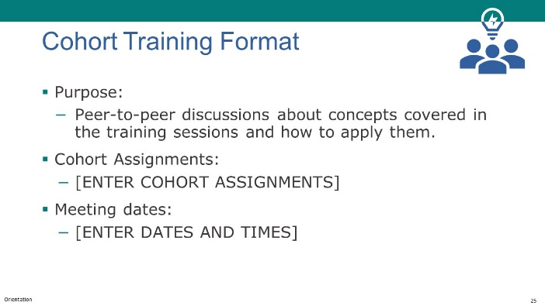
NOTE – IET Training Team:
- If you will be using cohorts in your Design Camp, use this slide to describe how they will work and when they will occur. If not, remove the slide in the PPT and in this facilitator guide.
Present:
- Explain the purpose of cohorts and how they will work.
- Purpose: Peer-to-peer opportunity to dive deeper into the concepts covered in the training sessions and how to apply what you’re learning to your own design work.
- How Cohorts will work: [ENTER EXPLANATION FOR HOW COHORTS ARE ORGANIZED, WHEN THEY WILL MEET, ETC.]
- NEXT SLIDE

Poll: Design Camp Materials (Optional)
Presenter: [NAME]
Duration: 2 min.
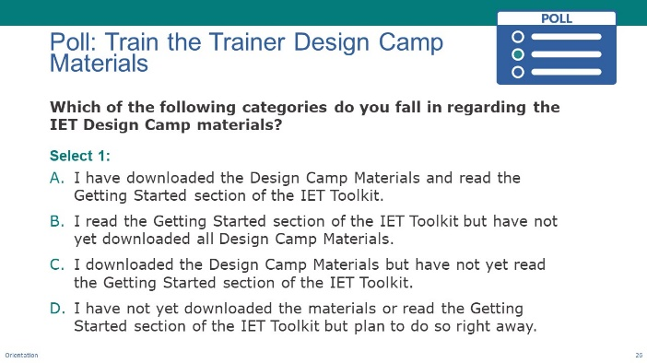
NOTE – IET Training Team:
- This is an optional slide. Delete or modify as needed. Remember to do the same in the slide deck.
Poll:
- Introduce the poll question and ask participants to respond.
- Prior to today, did you have a chance to download and look through the Design Camp materials?
- In-person: Raise your hand as I read the options.
- Virtual: Please select the response that best describes your situation.
- Ask technical assistant to share results (if virtual)
- Respond to the results
- NEXT SLIDE

What You Can Expect of US
Presenter: [NAME]
Duration: 1 min.
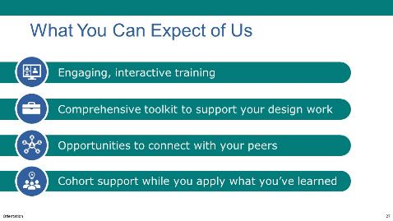
NOTE – IET Training Team:
- This is an optional slide.
- If you are not having cohorts, delete or modify the last item on the slide and below.
NOTE – Technical Assistant:
- This slide has 3 builds/clicks to display the expectations one a time as the facilitator discusses each.
Present:
- Discuss what participants can expect from the Design Camp.
- The Design Camp is designed to be engaging and interactive training that will require your active participation.
- We hope that you see the Toolkit as very comprehensive – it covers a lot!
- Throughout the training, there will be multiple opportunities to connect with your peers.
- Please reach out if you have questions about the Toolkit and use the cohort discussions to dig into specific areas that interest you.
- NEXT SLIDE

What We Expect of You
Presenter: [NAME]
Duration: 1 min.
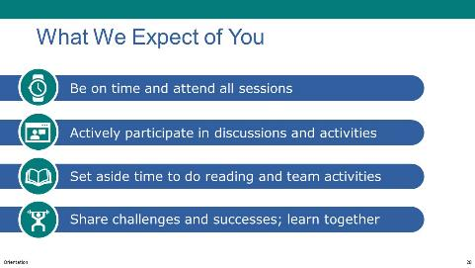
NOTE – IET Training Team:
- This is an optional slide. Delete, modify, or keep as is to fit your needs.
NOTE – Technical Assistant:
- This slide has 3 builds/clicks to display the expectations one a time as the facilitator discusses each.
Present:
- Discuss what you expect of participants.
- To ensure that you get the most out of the Design Camp, please do your best to be on time and attend all sessions.
- The experience will be much richer with active participation in the discussions and activities.
- Set aside time to do reading and team activities.
- Share challenges and successes; learn together
- NEXT SLIDE

Questions? (IET Design Camp Overview)
Presenter: [NAME]
Duration: 4 min.
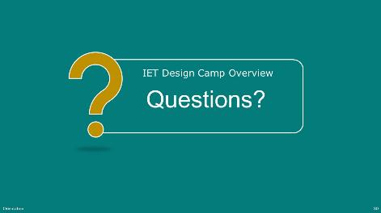
Present:
- Ask if there are any questions about the Design Camp.
- NEXT SLIDE

0-3 IET Toolkit Tour
Estimated Start Time: [ENTER TIME]

IET Toolkit Tour – Section Introduction
Presenter: [NAME]
Duration: 1 min.
Present:
- Introduce the topic and subtopics:
- Organizational structure of the Toolkit
- Self-Assessment
- Desk Aids and Tools
- NEXT SLIDE

Tour of the IET Toolkit: Organization
Presenter: [NAME]
Duration: 2 min.
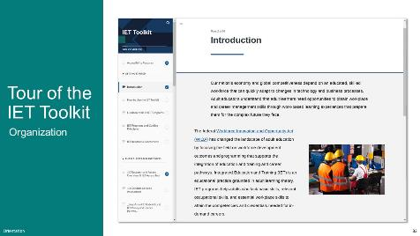
NOTE – IET Training Team:
- You can choose to use the PPT slides to review the IET Toolkit or share your screen and walk through the highlights. If you choose to share your screen, remove the next two slides, but add the talking points to this slide.
Present:
- Walk through the following key features of the IET Toolkit:
- Walk through navigation pane.
- Show general set-up of each section and hyperlinks, etc.
- NEXT SLIDE

Tour of the IET Toolkit: Self-Assessment
Presenter: [NAME]
Duration: 2 min.
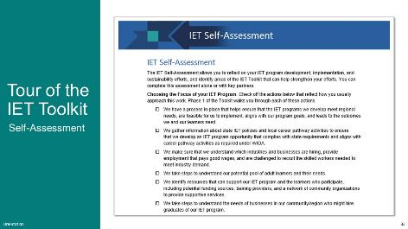
NOTE – IET Training Team:
- You may want to have local agencies/program teams complete the Self-Assessment in the Toolkit.
Present:
- Use the PPT slide to review the Toolkit Self-Assessment. Alternatively, use screenshare and review it from the Toolkit.
- The self-assessment is a high-level chance to reflect on where your team may need to focus or revisit. This is a great activity to do this week.
- It lets you reflect on your IET program development and implementation, and sustainability experience, and you will learn about ways that the Toolkit can support you.
- It’s designed to help you gauge perceptions and develop strategies for moving forward by identifying positions of strength in program design and implementation, as well as gaps or opportunities for growth related to program design and implementation.
- It may generate thoughts about what you want to learn as we move through each of the four phases, or specific work or challenges you have had.
- We strongly encourage you to take the self-assessment if you haven't done so already. You can do it on your own, or if you're here as a team, you could do it together.
- NEXT SLIDE

Tour of the IET Toolkit: Desk Aids/Resources
Presenter: [NAME]
Duration: 2 min.
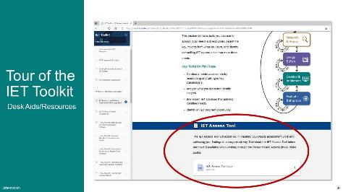
Present:
- Use the PPT slide to review the Toolkit desk aids and tools. Alternatively, use screenshare and review them directly from the Toolkit.
- What you're seeing here is how you're going to access the tools. These are fillable forms that let you map what you're learning and apply it directly to the IET design work that you're doing.
- No matter how you get to the Toolkit, whether you use the PDF or the web version, you’ll need to download the tools and put them in a folder on your drive, so that you can start customizing them and making them your own. We’ll be looking at and using some of those tools in the Design Camp.
- NEXT SLIDE

0-4 Wrap-Up
Estimated Start Time: [ENTER TIME]

Wrap-Up - Topic Intro
Presenter: [NAME]
Duration: 1 min.
Present:
- Explain that we will wrap up the session by:
- Reviewing some key takeaways.
- Reflecting on what you learned, what stood out to you, and what questions you may have.
- Conducting a quick poll.
- Going over next steps.
- NEXT SLIDE

4 Key Takeaways
Presenter: [NAME]
Duration: 2 min.
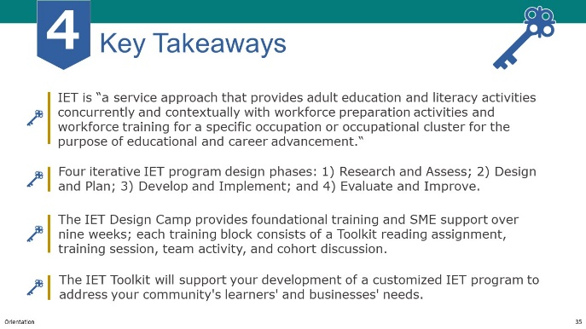
NOTE – Technical Assistant:
- This slide has 3 builds/clicks to display the key takeaways one a time as the facilitator discusses each.
Present:
- Review key takeaways.
- We set the foundation for what constitutes a quality IET program—specifically in terms of WIOA requirements.
- We previewed the 4 phases of the IET Design Process that will be the focus of each training session in the coming weeks.
- We reviewed the Design Camp structure and shared expectations for what you can expect from us, as well as what we expect of you as participants to ensure you get the most out of the experience.
- We reviewed the IET Toolkit and how it can support your development of a customized IET program to address the needs of your community, your learners, and the needs of your local businesses. If you haven’t had a chance to look at the Toolkit, please make some time to do so.
- NEXT SLIDE

Group Discussion: Reflection (Optional)
Presenter: [NAME]
Duration: 10 min.
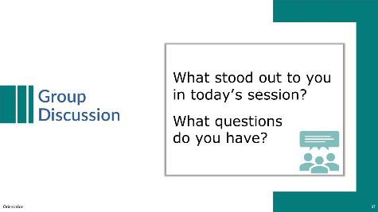
NOTE – IET Training Team:
- This is an optional discussion that can be conducted with the whole group of participants, or you may choose to conduct it in breakout groups and then ask groups to share one or two things they came up with.
Discuss:
- Lead a group discussion reflecting on what was covered in this Orientation.
Possible questions:
- What stood out to you in today’s session?
- Did anything surprise you? Confuse you?
- As time allows, ask if there are any questions about what was covered in this Orientation—whether about the definition and requirements of IET programs or about the Design Camp organizational structure or materials.
- NEXT SLIDE

Poll: Understanding of IET (Optional)
Presenter: [NAME]
Duration: 2 min.
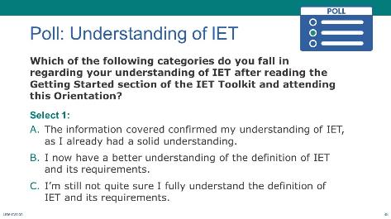
NOTE – IET Training Team:
- This is an optional poll. You can choose to delete or modify it as needed. Remember to do the same in the slide deck.
Poll:
- Introduce the poll question and ask participants to respond.
- Take a quick minute to let us know if you feel you have a stronger understanding this afternoon of an IET than you did prior to today.
- If virtual, ask technical assistant to share results.
- Respond to the results
- NEXT SLIDE

Next Steps
Presenter: [NAME]
Duration: 2 min.
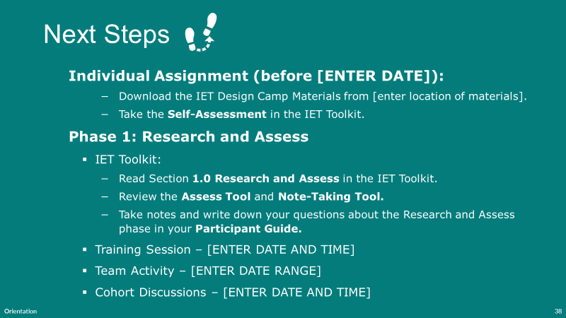
Present:
- Review next steps.
- Next week will be the Research and Assess training session. Prior to then, please take a few minutes to download the files and spend time reviewing the self-assessment.
- Read the first section of the Toolkit and related desk aids and familiarize yourself with the Participant Guide so you have ideas and questions ready for next week.
- Thank everyone for their participation and end session.

After the Session

Follow-Up Recommendations
Send an email to check in with participants and remind them of the homework assignment, the cohort meeting (if applicable), and the next Design Camp session.
Suggest that participants review the Research and Assess section of the IET Toolkit and download and review the IET Assess Tool and the Needs Assessment Note-Taking Tool before the next training session.
Remind participants to download the Participant Guide and write down any questions they have as they review the Research and Assess section of the IET Toolkit.
Share your state’s IET policies or guidelines (if applicable) and a roster of training participants and trainers.

